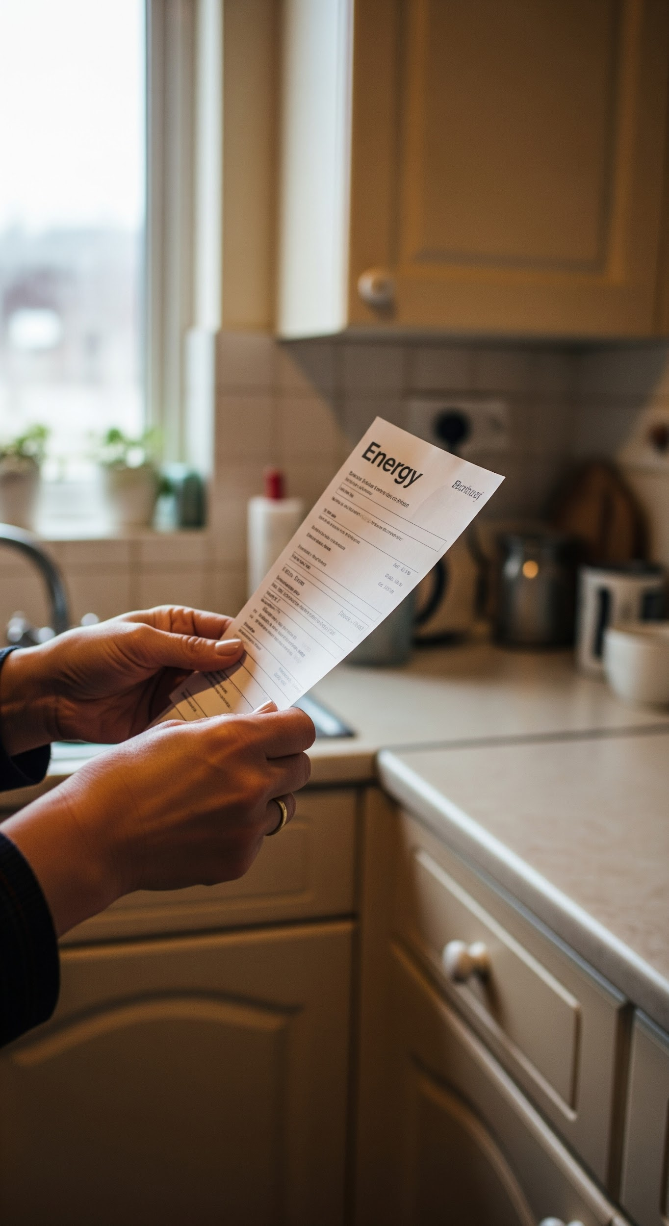

**Closing the fuel poverty gap: A plan for targeted energy support**

August 2025

# Contents

Contents 2

Acknowledgements 3

Executive summary 4

01 The affordability challenge 10

02 Method of targeted bill support 27

03 Designing targeted bill support 39

04 Finding households in need 51

Annex 59

Acknowledgements

This work was supported by a steering group chaired by Scope, comprising Age UK, EON, Fair By Design, Independent Age, Mencap and Sense. This report and its recommendations are entirely the authors' work. They kept editorial control during the project. We thank the steering group members and the many stakeholders who engaged with the research project and shared their views.

|  |
| --- |
| Sense logoMencap logoInserting image...Scope disability charity logoInserting image...Fair By Design logoAge UK logo |

### Authors

Amy Norman

Scott Corfe

Ines Wittke

Jordan Southwell

# Executive summary

Britain is still living through the aftershocks of the energy crisis. Although wholesale gas prices have eased from their peaks, household energy bills remain over £700 higher than in winter 2021. Households are struggling with ongoing affordability issues during a wider cost of living crisis. About 2 million are in debt or arrears, and up to 6.1 million are facing fuel poverty across the UK. A growing fuel poverty gap also deepens the problem, which has nearly doubled since 2020 and now stands at over £400 in England.

There are several initiatives to help households with energy costs. These include debt repayment schemes, energy efficiency upgrades, and targeted bill support. Since the energy crisis, many in the sector now use the term ‘social tariff.’ It refers to various ideas that help vulnerable customers get discounts on their bills. This report looks at targeted bill support. This means applying a discount to a customer’s current tariff as a rebate, instead of creating a new tariff structure. This means that customers would still be able to benefit from targeted bill support even if they changed their tariff or supplier. The Warm Home Discount (WHD) is the current primary mechanism for support across Britain. But it will expire in April 2026, putting 6 million households at risk unless a better, long-term solution is found.

This report, commissioned by a steering group of NGO and industry partners and written by Public First, outlines a clear plan to protect vulnerable energy customers with better targeted bill support. The report recommends extending and improving the Warm Home Discount after April 2026. This payment will give auto-enrolled, tiered support. It should be updated each year based on changes in energy costs.

Understanding the affordability challenge

Public First analysis shows that low income is the key factor in energy affordability. Nearly 72% of households that spend over 10% of their income on energy bills, after housing costs, are below the poverty line. Given that the most extreme cases of fuel poverty are, in practice, a reflection of wider poverty, income should be central to the design and targeting of any targeted bill support, ensuring support reaches those facing the greatest strain.

Income isn't the only factor. Disabled households are almost twice as likely to face fuel poverty compared to non-disabled ones. This often happens because they have higher energy needs from medical equipment or spend more time at home. Public First analysis shows that disabled households pay £86-£97 more per year for energy than non-disabled households. Older households (65+) also face higher rates of fuel poverty due to compounding vulnerable circumstances of worse health outcomes. Those paying by standard credit also shoulder additional costs of around £100 per year compared to direct debit customers. These households can't just “use less” energy to lower their bills. Their higher energy use is essential and needs direct support.

Existing schemes, however, do not address these realities. The recent expansion of the WHD eligibility is welcome, now providing 6.1 million British households with £150 payments, up from 3.4 million in 2023/24. This expansion doesn't cover disability benefit claimants. It mainly focuses on welfare eligibility. This means it misses households that don’t receive qualifying benefits but still struggle with affordability. Public First's analysis shows that the expanded WHD leaves out more fuel-poor households than it helps. Not everyone who gains support is considered fuel poor. Fuel poor means spending more than 10% of household income on energy after housing costs. About 2.5 million fuel-poor households are not included in the expanded WHD. Most of these, around 2.2 million, are low-income, disabled, or older households, often overlapping.

### Finding a better way

To fill these gaps, Public First looked at three possible models for providing targeted bill support. The analysis was modelled on the Living Cost and Food Survey – further methodological notes can be found in the annex.

* **A unit-rate discount:** a percentage reduction on the price per unit of energy consumed;
* **A payment-based discount:** fixed annual payments delivered via energy bills;
* **A rising block tariff:** discounts on the first block of energy consumption, with higher rates thereafter.

The findings demonstrate that:

* A rising block tariff may raise bills for vulnerable customers who use a lot, including the poorest and disabled.
* A unit-rate discount offers deeper support for some but comes at significantly higher costs and tends to deliver less value for money. Additionally unit rate models are more complex to integrate with an evolving market of dynamic, Time of Use pricing.
* **A payment-based discount strikes the best balance, lifting more households out of fuel poverty per pound spent.** A £400 fixed payment, based on WHD eligibility, could reduce fuel poverty similarly to a 30% unit rate discount. However, it would cost about £0.5bn less each year.

Public First also modelled ways in which a payment-based model could overcome the targeting limits of the welfare system. A better model would focus on households based on income and other signs of high energy need. This includes factors like disability, payment type, and energy use, not just benefit receipt. Modelling indicates that an income-linked payment could gradually reduce support. It would start at £700 for those with the lowest incomes and extend up to a threshold of £30,000 annual household income. Adding £100 booster payments for all disabled households and income-eligible standard credit households would give extra help to those facing multiple vulnerable circumstances. This scheme will cost £4.1bn and help over a million households escape fuel poverty. About 360,000 of these are older households (65+) and 720,000 are disabled households (not mutually exclusive). Most households eligible for the expanded WHD (70% or 3.6 million) would qualify for this scheme. It would also help an additional 5 million households that don’t currently receive any targeted bill support.

Policymakers should commit to adjusting support each year. This adjustment could relate to the price cap, the average fuel poverty gap, or other market factors.

How support is funded also matters. A fully government-funded bill discount scheme is better. It's more progressive through the tax system than through bills. Fiscal limits on public spending restrict the size, generosity, and feasibility of a targeted bill support scheme. Policymakers should consider a mixed funding approach. This would be partly funded by taxpayers and billpayers.

### How to deliver support

Creating a fairer and more effective bill support system needs fresh methods to identify and assist households in need. It will probably take 18 months to two years for the government to create the data matching system. This includes the needed laws and safeguards for a bill payment method that helps vulnerable customers not in the welfare system. As such, policymakers should aim for the payments to be implemented by Winter 2027/28.

**1. Data integration and matching to reach households beyond the welfare system**

* Create a data-sharing framework that connects different departments. This includes HMRC for income data, DWP for benefits data, NHS and DHSC for health and disability indicators, and energy suppliers for consumption and payment method data.
* Appoint a trusted data processor, like DWP or an independent public body, to manage sensitive data securely. Provide suppliers with only anonymised eligibility flags.
* Triangulate address data by cross-referencing council tax records, HMRC income data, and supplier info. This helps to accurately combine household incomes, reducing the risk of under- or over-targeting.
* Refine the Priority Services Register (PSR) needs codes. This will help identify vulnerable households, especially disabled customers who may not receive benefits but have high energy needs.

**2. Legislative change**

Updating the Digital Economy Act 2017 is essential. This will broaden its focus from just fuel poverty to include more support for affordability and vulnerability. This would let departments share data legally and improve information flow between the government, suppliers, and the data processor, all while following GDPR rules. Drafting this legislation in 2025 and passing it by 2026 is critical to ensuring an improved system is in place by Winter 2027/28.

**3. Supplementary referral and application routes**

Even with improved data matching, Some households might still be missed due to inaccurate data or sudden 'crisis' situations. The system should therefore include:

* Social prescribing pathways build on the success of Warm Homes Prescription pilots. They enable health professionals and local services to refer households for bill support.
* Self-referral tools help households facing sudden shocks, like job loss or bereavement. They make it easy to access support quickly.
* Continued Industry Initiatives, part of the Warm Home Discount, can help more households. They assist those at risk of fuel poverty, even if they don’t meet the usual criteria. Support includes energy efficiency measures, debt advice, and guidance on energy and smart meters.

### A plan for reform

The report recommends an ambitious but achievable roadmap. In the near term, to ensure households in need are not left with a cliff-edge of support, the government should extend the WHD to April 2027. To tackle rising fuel poverty, the government should raise support to £400. It should also add £100 booster payments for disability benefit claimants and eligible customers on standard credit. This will cost £2.7bn a year in total or an average of £93 per billpayer if funded entirely on bills. It would also bring over half a million households out of fuel poverty, compared to around 160,000 under the current £150 WHD scheme.

By winter 2025, a consultation on a new targeted bill support scheme should start. At the same time, work will begin to draft and pass primary legislation. This will update the Digital Economy Act for secure data sharing.

From 2026, the government should start a new payment scheme linked to income. They need to set up a data-sharing framework across departments. By winter 2027/28, they must also build the systems to provide automatic support. Alongside this, investing in social prescribing and self-referral routes will help ensure no vulnerable customers are overlooked.

If the rollout of a new targeted bill support system is delayed, policymakers need to ensure support continues without interruption. They should also consider extending the WHD for a second year, until April 2028.

A summary of these recommendations and an implementable timeline is below.

**Summary of policy recommendations and timeline**

|  |  |  |  |  |  |
| --- | --- | --- | --- | --- | --- |
| **Action** | **Responsibility** | **2025** | **2026** | **2027** | **2028** |
| Extend the WHD to April 2027, increasing eligibility value to £400 plus booster payments | DESNZ/HMT | x |  |  |  |
| Launch the target bill support consultation by Autumn 2025 | DESNZ | x |  |  |  |
| Keep ministerial working group on data matching in place until full implementation | DESNZ | x | x | x | x |
| Draft primary legislation to update the Digital Economy Act 2017 | DESNZ | x |  |  |  |
| Pass the legislation through parliament | DESNZ |  | x |  |  |
| Appoint a trusted data processor (e.g. DWP or third-party) | DESNZ |  | x |  |  |
| Pilot triangulation of household address data | HMRC, VOA/local authorities & suppliers |  | x |  |  |
| Apply lessons from Warm Homes Prescription pilots to scale social prescribing | Appointed data processor, suppliers & healthcare providers |  | x | x |  |
| Invest in building inclusive, well-designed self-referral tools | Appointed data processor & suppliers |  | x | x |  |
| Undertake an analysis of potential health-based needs codes for the Priority Services Register | Ofgem, DNOs, GDNs, Ofwat, water companies, suppliers & healthcare providers |  | x |  |  |
| Implement needs codes for the Priority Services Register | Ofgem & suppliers |  | x | x |  |
| Complete household aggregation of income data | HMRC |  |  | x |  |
| Implement a formula-based income-linked targeted bill support payment | DESNZ, HMT, appointed data processor & suppliers |  |  | x | x |

Note: For accessibility, the x denotes a coloured square in the timeline.

# 01 The affordability challenge

Energy bills are unaffordable for millions of households, which is driving a wider cost of living crisis. Recent polling by Public First finds that households are most likely to say the cost of living is the most important issue facing the country at this time.[1] As households struggle to afford essentials, many are falling behind in their energy bill payments or cutting back on their usage. The most recent official figures from Ofgem show that around 2 million have fallen into debt and arrears on their energy bills in Q1 2025, totalling £4.15bn.[2] As well as this, nearly 800,000 households on smart prepayment meters were self-disconnecting at least once to ration their consumption.[3] As of January 2025, National Energy Action estimates that 6.1 million UK households are in fuel poverty.

Multiple factors influence this affordability challenge, including elevated prices following the recent gas crisis, as well as household and property circumstances that lead to high energy needs. This chapter examines these factors in more detail as well as the current landscape for bill support, whereby the primary mechanism – the Warm Home Discount – is set to end in April 2026, highlighting the urgent need to address the affordability gap.

This report makes the case for ensuring vulnerable energy customers are protected beyond 2026 through an improved mechanism of targeted bill support.

In this report, we use the term “vulnerable customers” as it reflects established terminology in the energy sector for households with high energy needs and affordability challenges. We recognise that Scope and other stakeholders do not use this language and instead use the social model of disability. We know this language implies a fixed or deficit-based view of disabled people’s lives, rather than recognising the barriers people face and the changes needed to create equality.

### Energy prices have not returned to pre-crisis levels.

The energy crisis of 2021-2023 has left a lasting impact on British households. Prices remain well above pre-crisis levels - on average, household energy bills today are over £700 (73%) more expensive than in winter 2021.[4] This long tail of the crisis has a debilitating effect on households’ financial security and quality of life.

This has led to heightened concerns about the extent and depth of fuel poverty. Estimates in England suggest that on average, the fuel poverty gap, which measures the amount by which energy bills would have to reduce to lift a household out of fuel poverty, now stands at £407, up from £223 in 2020, before the crisis.[5]

**Figure 1: Average energy bills remain above pre-crisis levels.** Direct Debit Price Cap, 2019-2025.

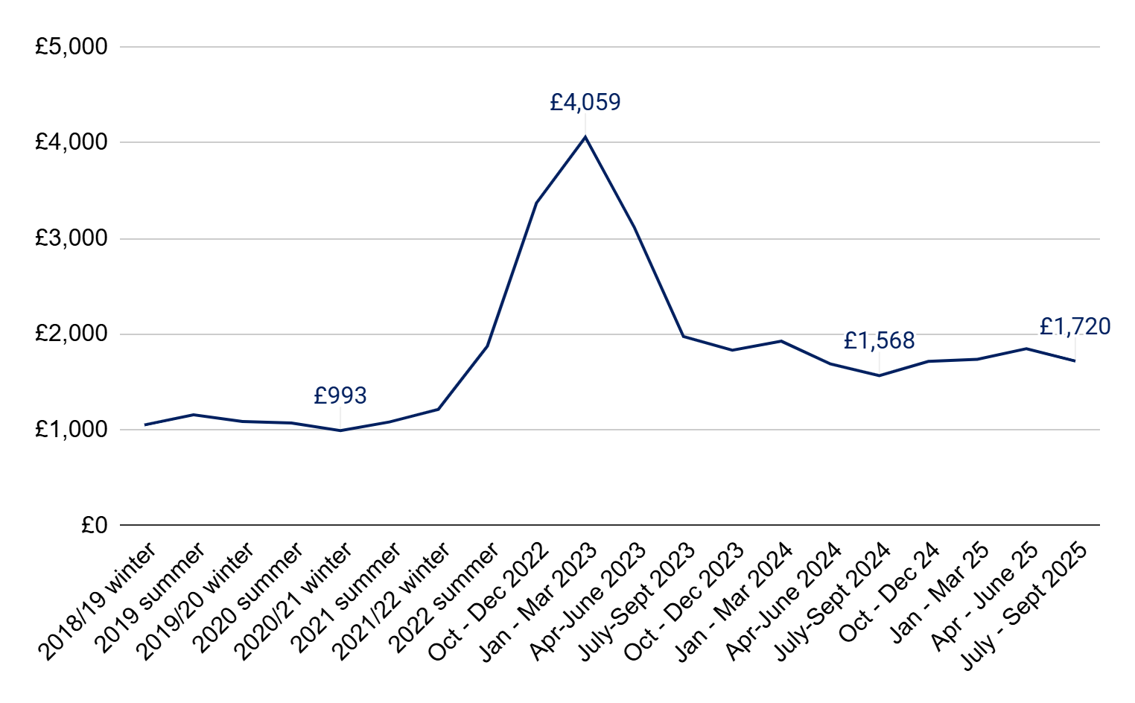

Source: Ofgem

As a devolved issue, fuel poverty is defined and measured differently across the nations. England uses a Low Income Low Energy Efficiency (LILEE) metric, which considers both household income and the efficiency of the home to capture the fact that some homes are poorly insulated and harder to heat. Using this definition, official statistics estimate that 2.7 million (11%) English households were fuel poor in 2024.[6] By comparison, devolved nations use an affordability measure, defined as a household spending more than 10% of their income after housing costs on energy bills while maintaining an adequate heating regime – the heating regime metric is also set by each nation based on the home’s physical characteristics. As such, the LILEE measure risks underestimating the level of households experiencing affordability challenges and fuel poverty, missing those in need of support. This is primarily because the LILEE definition does not address the income-to-spend ratio in energy, meaning that a household above low-income or living in a more efficient home with high energy needs would not be considered fuel poor.

Scotland had an estimated 850,000 (34%) households living in fuel poverty in 2024.[7] Additionally, Wales has not produced official estimates of fuel poverty since 2021 compared to more timely estimates from England (2024) and Scotland (2023). It is therefore unclear to what extent the energy crisis has impacted fuel poverty among Welsh households. The most recent official figure for fuel poverty in Northern Ireland was in 2016 at 22%.[8] However, in September 2024, polling by LucidTalk commissioned by National Energy Action found that 40% of Nothern Irish adults reported they were spending over 10% of their total household income on energy costs.[9] A standardised approach to data collection across the devolved nations could help policymakers and wider stakeholders evaluate the success of various schemes across the devolved nations.

Across the UK, National Energy Action (NEA) estimates that the crisis caused fuel poverty to rise by 36% from 4.5 million households in October 2021 to 6.1 million in January 2025.[10] This estimate uses a version of the 10% definition, where a household spends over 10% of its income on energy to provide a satisfactory heating regime. NEA defines a satisfactory heating regime as the level of heating needed to maintain a comfortable and healthy indoor temperature, typically within a range deemed acceptable for human health and well-being.

As a result, the Committee on Fuel Poverty calls for the LILEE metric to be reviewed as it no longer captures the full range of households facing unaffordable bills.[11] In light of this, and to maintain consistency across the devolved nations, Public First’s analysis in this report uses the following definition when discussing the distributional impacts of policy options on fuel poverty: households spending more than 10% of their income after housing costs on energy bills.

Analysis by Public First shows that LILEE greatly underestimates the fuel poverty rate in the poorest decile (1), indicating that 39% of these households are fuel poor compared to 57% under the 10% affordability measure definition.

The analysis in this report is focused on Great Britian, although policymakers should consider how targeted bill support should be devolved to Northern Ireland through Barnett consequentials.

**Figure 2: LILEE underestimates the rates of fuel poverty among the lowest incomes compared to the 10% affordability measure.** Percentage of households in fuel poverty by income decile.

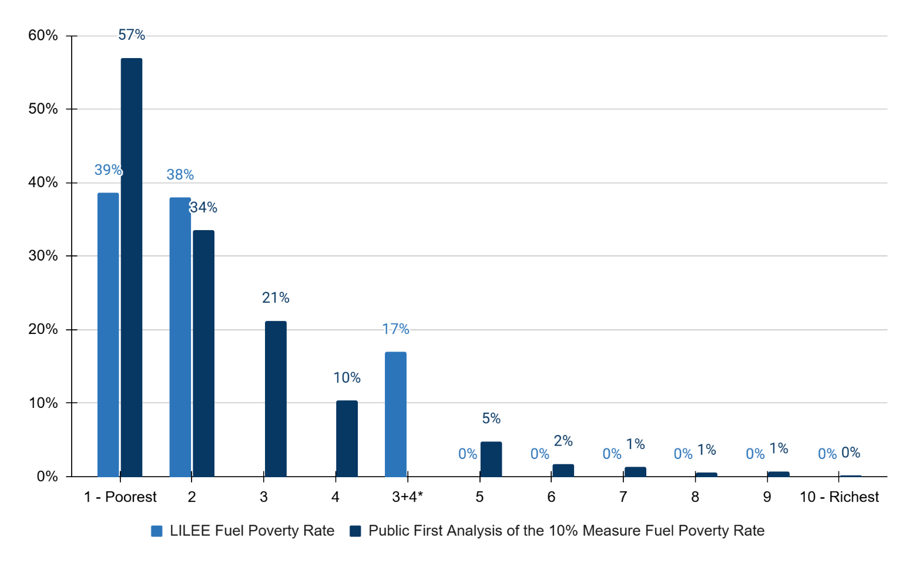

Source: Fuel poverty statistics 2025 (2024 data), DESNZ and Public First analysis of Living Cost and Food Survey (2022/23) uprated to 2025

Note: Deciles 3 and 4 are presented as grouped in DESNZ’s fuel poverty statistics.

Income is a key predictor of energy affordability.

Public First analysis finds that nearly three quarters (72%) of households spending more than 10% of their income after housing costs on energy bills are also below the poverty line, as shown in Figure 8. We also find that ‘deep fuel poverty’ (i.e. households spending more than 20% of their income after housing costs on energy bills) is almost entirely a reflection of poverty in a broader sense, as shown in Figure 3. Around 99% of these households are also below the poverty line. Given that the most extreme cases of fuel poverty are, in practice, a reflection of wider poverty, income should be central to the design and targeting of any targeted bill support, ensuring support reaches those facing the greatest strain.

**Figure 3: Income is a very strong predictor of deep fuel poverty (>20% of income spent on energy).** Euler chart illustrating the relationship between fuel poverty and poverty, disability, age, and WHD benefits, GB.

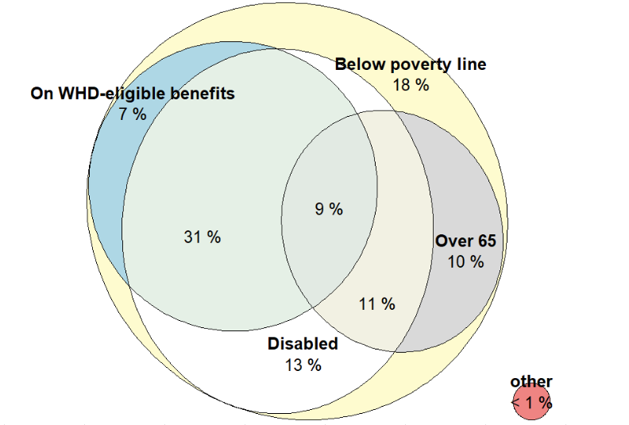

Source: Public First analysis of Living Cost and Food Survey (2022/23)

Note: Poverty is defined as below 60% of the median equivalised household income after housing costs.

### Households with higher energy needs also face affordability challenges.

A household’s ability to afford energy is not just about income, it is also shaped by how much energy they need to use. Households with high energy needs typically require greater consumption to maintain a basic standard of living, due to a range of structural factors. These needs are often driven by household or property characteristics including disability, the age or size of the household, and the energy efficiency of the home. While government and industry schemes exist to support property upgrades, some factors are difficult or impossible to change - for instance, if a member of the household requires electrical medical equipment or if their circumstances require them to be at home more often. These households are unlikely to be able to reduce their usage meaningfully and safely, and would therefore require more targeted support to keep energy costs affordable.

Public First’s analysis finds that fuel poverty rates are twice as high among disabled households (18-20%) than non-disabled households (9%). In real terms, Public First estimates that there are around 1.5 million non-disabled fuel poor households, compared to 2.2 million fuel poor disabled households, as covered by the Equality Act 2010. Within this latter group, around 0.8 million households are claiming disability benefits of ESA, PIP, DLA, Carers Allowance or Attendance Allowance – this means less than half of the disabled households in fuel poverty are currently receiving disability benefits.

Higher rates of fuel poverty among disabled households are driven by multiple factors that increase energy needs, such as limited mobility, which means members are more likely to stay home, relying on medical equipment, and requiring warmer temperatures to prevent worse health outcomes. Disabled households are also more likely to have lower incomes, compounding aspects of fuel poverty that are driven by financial vulnerabilities.[12]

**Figure 4: Fuel poverty is up to twice as common in disabled households than non-disabled households.** Percentage of households in fuel poverty (left axis) and millions of households in fuel poverty (right axis), >10% of AHC income spent on energy definition, by disability status, GB.

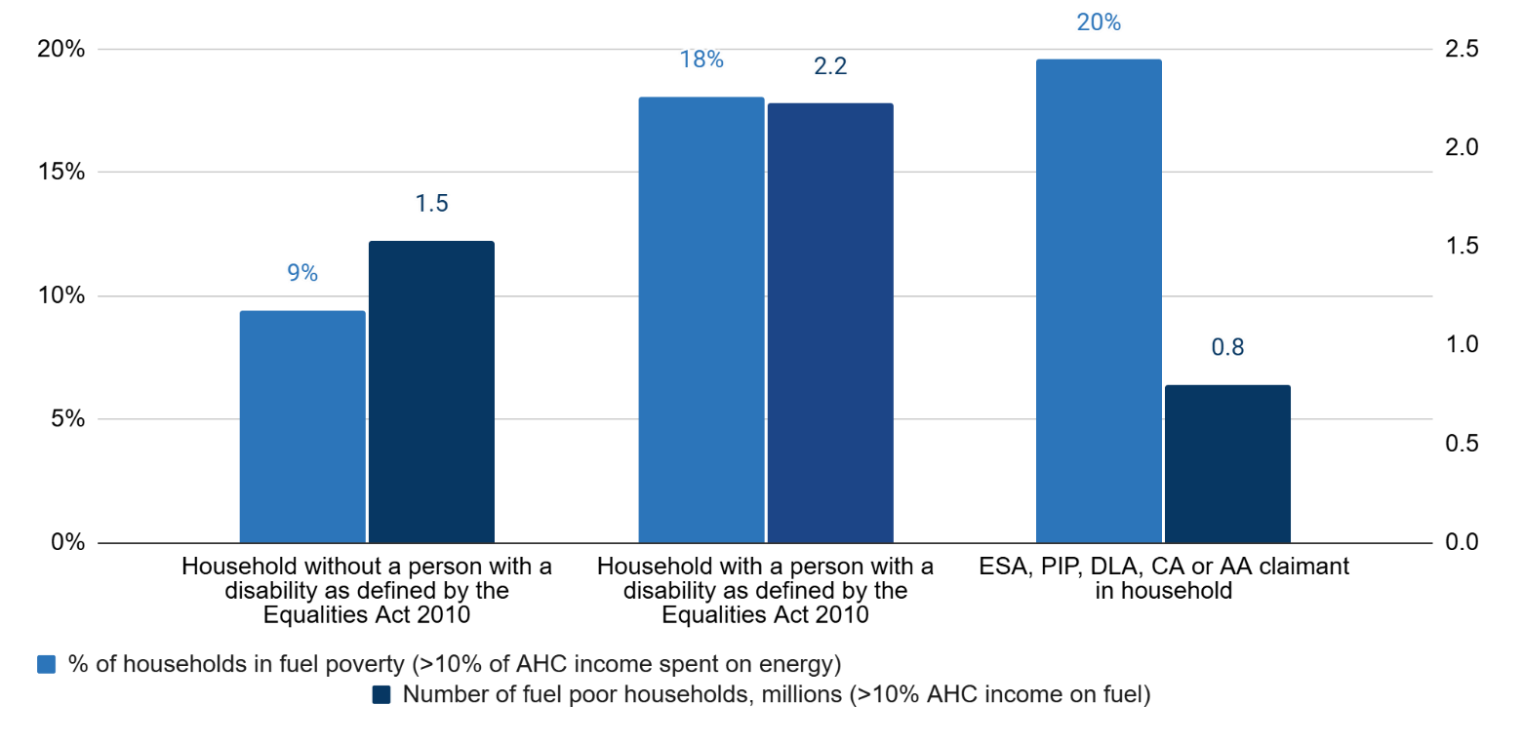

Source: Public First analysis of Living Cost and Food Survey (2022/23)

Fuel poverty is also linked to age - 1.5 times more older households (65+) are in fuel poverty (15%) compared to younger households (aged 20-35, 10%). Overall, Public First estimates there are around 1.3 million older households (65+) in fuel poverty in Britain. Research for the Committee on Fuel Poverty suggests that fuel poverty in older households is partly driven by worse health outcomes in older age, whereby households may rely on medical equipment or require higher levels of heating to stay warm.[13]

**Figure 5: Older households (65+) are over 1.5 times more likely to be in fuel poverty than younger households (aged 20-35).** Percentage of households in fuel poverty (>10% of AHC income spent on energy) by age, GB.

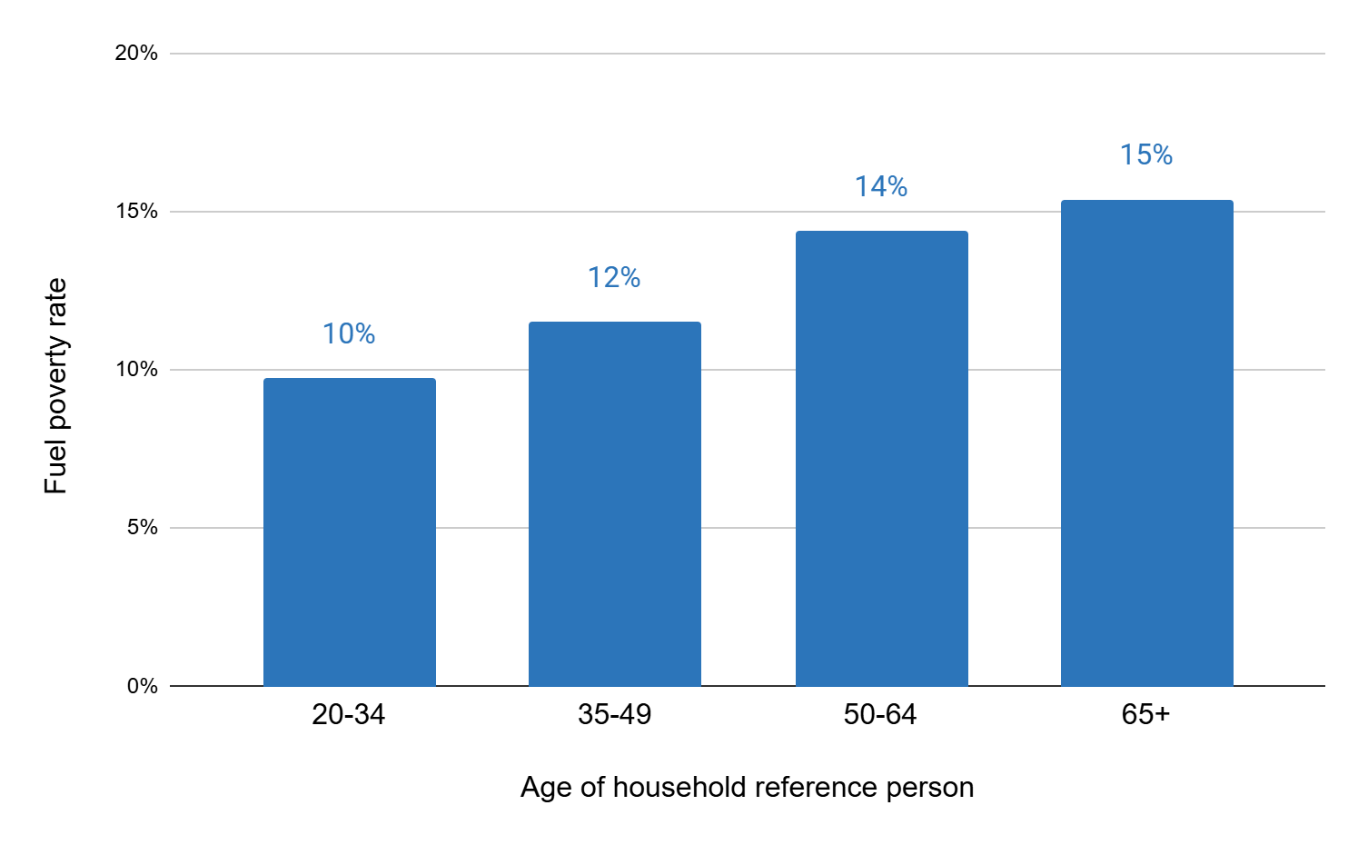

Source: Public First analysis of Living Cost and Food Survey (2022/23)

Affordability is also related to how households pay for their energy. Historically, prepayment meter customers faced higher standing charges and fewer tariff options meant these households paid a premium on their energy consumption, compared to direct debit households. During the energy crisis, the previous government scrapped the prepayment meter premium following significant public debate on the grounds of fairness. While prepayment meter households still see higher rates of fuel poverty compared to direct debit and standard credit users, this is now more closely associated with wider aspects of vulnerability that prepayment meter customers are more likely to experience, such as low and/or unpredictable income, and disability and health conditions which can lead to forced installations and ‘self-disconnecting’ i.e. not topping up out of choice or necessity. This may mean that households on prepayment meters are unable to meet their energy needs sufficiently, compared to households using other payment methods.

Standard credit customers face the deepest fuel poverty premium of all payment methods at around £100 more in electricity than the average fuel poverty gap (£407). The gap is also growing, now standing at its largest (except for at the height of the energy crisis when the Energy Price Guarantee was in place) and could likely continue. This is largely driven by the levels of consumer debt paid for by standard credit customers, as well as a small premium for covering the cost of serving these customers through posting bills and manually processing payments.

**Figure 6: Standard credit customers face the deepest fuel poverty premium.** Average fuel poverty gap by payment method, GB.

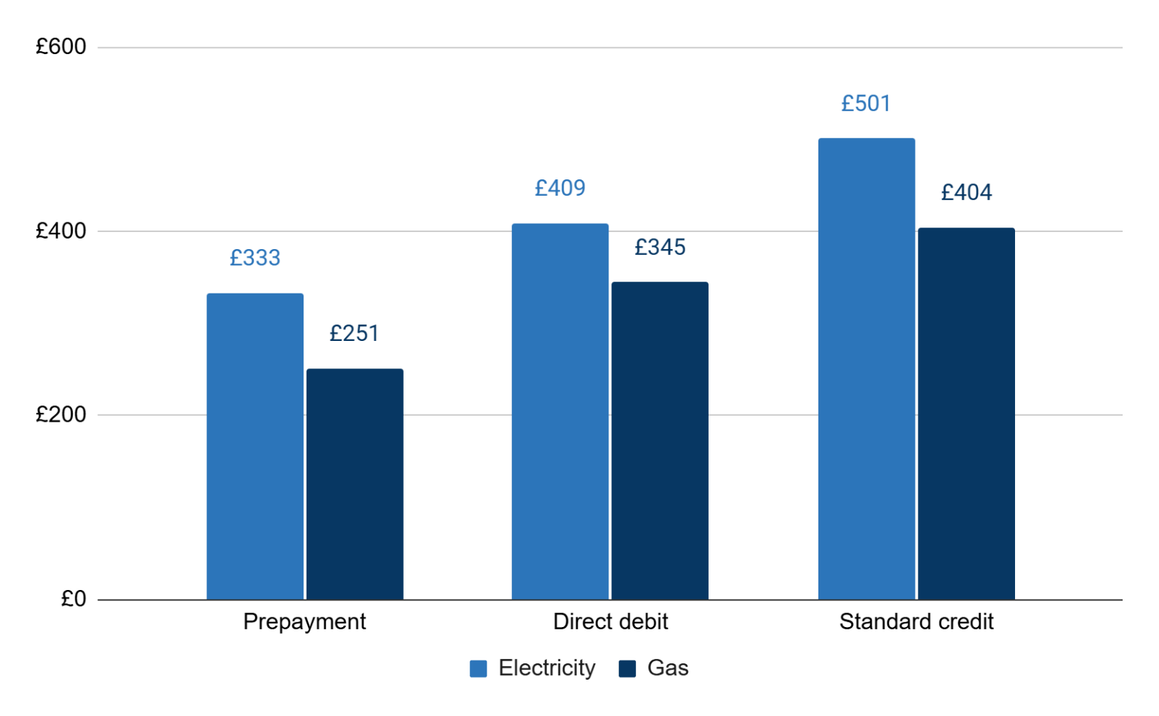

Source: DESNZ, Fuel Poverty Statistics 2025 (2024 data)

Energy efficiency is also a key driver of fuel poverty, as less efficient homes require more energy, and therefore cost more, to heat and power. While our analysis cannot account for efficiency directly, as EPC data is not included in the Living Cost and Food Survey, government data on the English LILEE fuel poverty metric demonstrates its impact on fuel poverty. It is worth noting that the Government’s LILEE metric sets an absolute threshold above which it considers that a household cannot be fuel-poor (FPEER band C) regardless of income. The latest fuel poverty statistics in England show that while the majority (83%) of fuel poor households fall just below the efficiency threshold (FPEER band D), the fuel poverty gap between households in bands F and G is over £1,500 higher than for 163,000 households in band D.[14] Energy efficiency, therefore, does not just influence who is fuel poor, it also shapes the severity of their experience.

### Current targeted bill support mechanisms require improvements to adequately tackle the affordability challenge.

Various initiatives exist to support households with energy affordability, including debt repayment schemes, energy efficiency upgrades, and targeted bill support. This report is focused on the latter, also referred to as an energy bill discount. Since the energy crisis, many across the sector have come to use the term ‘social tariff’ to mean a wide range of proposed mechanisms that provide enable vulnerable customers to benefit from a discount on their bills.

Social tariffs exist, although in varied forms, across other utilities like water and telecomms. As costs increase across the economy and bills for water and energy rise, many stakeholders have called for existing mechanisms to be reconsidered. For example, The Independent Water Commission led by Sir Jon Cunliffe recently recommended “the introduction of a national social tariff [in water] to provide consistent support for low-income customers who need support to pay their bills. This will help address the widely different levels of support currently in place, with caps on bills varying by £100s in different parts of the country.”[15]

Historically, social tariffs were discounted tariffs offered voluntarily by energy suppliers to eligible customers. While they were encouraged by government and the regulator in the early 2000s, their offering relied on the supplier’s own volition, and so eligibility and discounts varied across different suppliers. Given the design of a fixed tariff, customers were then less able to benefit from competitive prices - studies at the time found that customers on these tariffs could get an even better deal in the open market by switching.[16] This report is focused on targeted bill support, meaning a discount that is applied to a customer’s existing tariff choice as a rebate, rather than a separate tariff structure. This means that customers would still be able to benefit from targeted bill support even if they changed their tariff or supplier.

The current approach to targeted bill support largely relies on the Warm Home Discount (explained in more detail below), which is due to end in April 2026. After which, around 6 million vulnerable customers will see their energy bills increase as the rebate is removed. The report ultimately recommends building on the Warm Home Discount by extending and improving it beyond April 2026 to provide deeper support to a wider set of vulnerable customers beyond the welfare system. The details of this are explored in later chapters. This section examines the current design of the WHD, including its eligibility, depth of support and impact.

### Warm Home Discount (WHD)

Currently, the main form of targeted bill support is the Warm Home Discount (WHD). This scheme provides a £150 rebate to eligible households within the welfare system, funded through a levy on all billpayers and currently averaging around £21 a year.

Since its introduction in April 2011, the WHD scheme has provided support to millions of households every year, helping them cover their energy costs through the coldest periods.

In its first year, just under a million households received a rebate via the WHD scheme, rising consistently to 2015/16 before stagnating at around 2.2 million households until 2022. This past winter (2024/25) saw the most beneficiaries from the WHD in its history with 3.2 million households.

Beyond just easing the immediate financial pressures, the scheme has also very likely contributed to improved overall health outcomes by reducing the rate of cold-related issues, such as respiratory illness and excess winter deaths, highlighted in previous government policy evaluations.

**Figure 7: The WHD has supported millions of households per year since it was introduced in 2011.** Number of households receiving rebates from the WHD scheme since it began in 2011, GB*.*

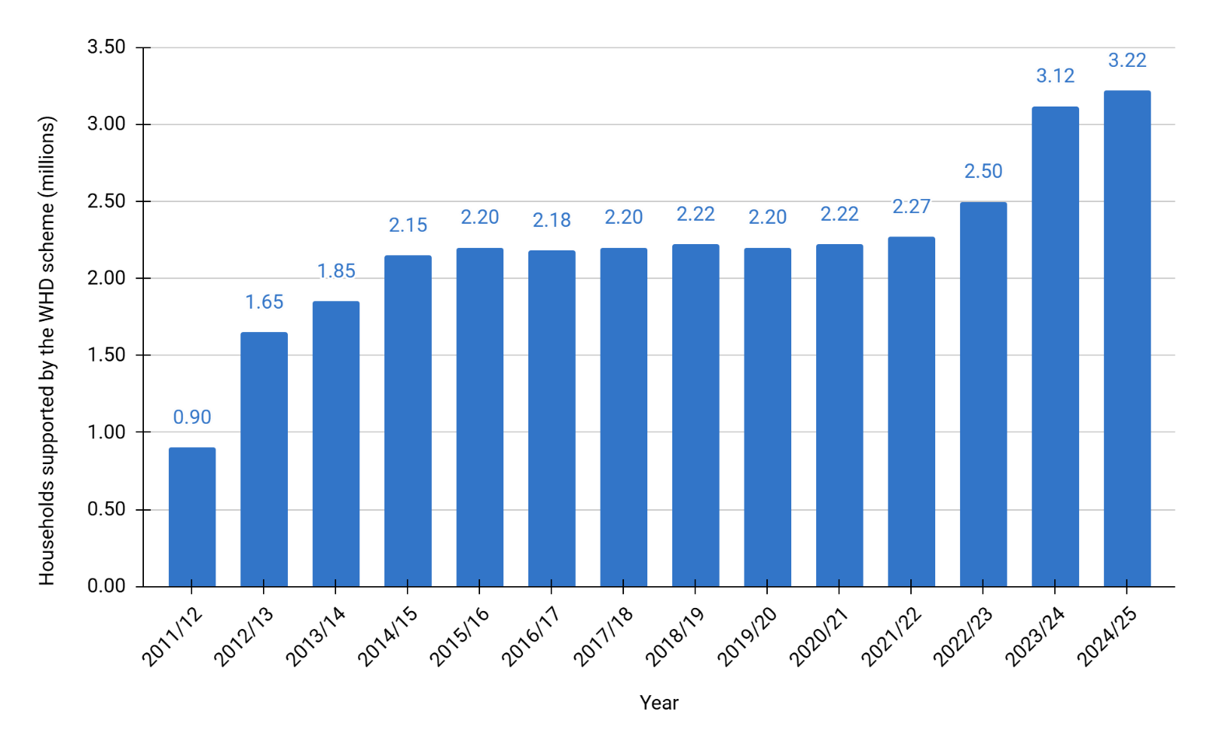

Source: DESNZ Warm Homes Discount Statistics 2024/25

### Eligibility

Eligibility for the WHD varies across the devolved nations but is broadly divided into two groups. England and Wales have Core Group 1 which consists of pensioners receiving the Guarantee Credit element of Pension Credit and Core Group 2 covers low-income households that the government identifies as most likely to have high heating costs. This required matching property data with means-tested benefits and tax credit data to confirm eligibility. Eligible claimants included working-age households in receipt of certain means-tested benefits including Income Support, income-based Jobseeker’s Allowance, income-related Employment and Support Allowance, Housing Benefit, and certain tax credits. Scotland’s scheme has a Core Group, which works the same as England and Wales’ Core Group 1, and a Broader Group which is for customers identified by their supplier as being at risk of fuel poverty. While England and Wales’ scheme auto-enrols eligible households across both groups, under Scotland’s Broader Group, qualifying customers need to apply to their energy supplier. In future, aligning Scotland’s eligibility criteria and auto enrolment with England and Wales could improve efficiency and ensure equitable support across Great Britian.

There is also another element to the WHD, known as industry initiatives which provides wider help for fuel poor customers, as part of a supplier spending obligation. This represents around 10% of the total WHD budget and is mostly spent on energy efficiency measures, as well as some other wider support programmes like debt, energy, and smart meter advice.￼ Critically, industry initiatives are accessible to customers outside of the WHD eligibility criteria, meaning the schemes can reach many households at risk of fuel poverty as well.

In June 2025, the government announced an expansion of the Warm Home Discount ahead of winter to remove the high-cost-to-heat threshold. This change effectively makes all households in which the billpayer or their partner (or an appointee of someone who) receives means-tested benefits eligible for the scheme. Although, notably, this expansion does not include disability benefit claimants. The government estimates that this would expand support to more low-income and fuel poor households, although with less precision, providing support to 6.1 million British households, up from 3.4 million in winter 2023/24. The actual number of households who receive the discount will depend on several factors: the number of eligible benefit recipients, whether they are named on the electricity account, data-matching success rates, and how many respond to invitations to claim the rebate.[17] This broader eligibility will also increase the scheme’s total cost to £1bn, raising the average annual cost for an individual billpayer to £37.

While the expansion of the scheme has been welcomed by many stakeholders, Public First research indicates that the majority of fuel poor households will still be ineligible for support. Public First analysis estimates that around 33% (1.2 million) of fuel poor households will be eligible for the expanded WHD scheme, compared to around 67% (2.5 million) of fuel poor households that would miss out on the much-needed support (using the definition of spending over 10% of their income after housing costs on energy). The majority of those in fuel poverty missing out – 60 of the 67 percentage points (2.2 million) - are low-income, disabled and/or older households, most of which intersect, as shown in Figure 6. As a result, the following statistics for each household characteristic should not be combined due to double counting. Of the fuel poor households who are ineligible for expanded WHD support, Public First estimates that:

* 34 of the 67 percentage points (1.3 million) are older households, over 65;
* 35 of the 67 percentage points (1.3 million) are households where a member is disabled, as defined under the Equality Act 2010;
* 41 of the 67 percentage points (1.5 million) are low-income households, below the poverty line.

The government’s analysis estimates a smaller number of households will miss out from the expanded criteria - 55% compared to Public First’s estimated 67%. Official documents quote this same estimate of 55% for both the LILEE definition and the affordability definition of fuel poverty.[18] While it is possible that the modelling does not capture the full extent of removing the ‘high-cost-to-heat’ group, the core issue remains: even the expanded WHD excludes more fuel-poor households than it reaches.

**Figure 8: The majority of British fuel poor households are ineligible for WHD.** Euler chart on the relationship between WHD eligibility, poverty, disability status and age, GB.

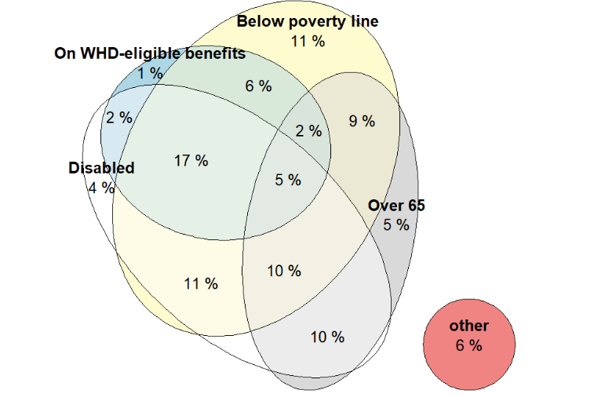

Source: Public First analysis of Living Cost and Food Survey (2022/23)

Note: Poverty is defined as below 60% of the median equivalised household income after housing costs.

The depth of support provided by WHD is also currently insufficient to meet the affordability crisis. The £150 rebate falls far short of the average fuel poverty gap, which now stands over £400.[19] Public First analysis suggests that, while the expanded WHD would benefit more fuel-poor households, fewer than 5% of the estimated 6.1 million beneficiaries would be lifted out of fuel poverty as a result of the payment. As well as this, the £150 value has not been uprated in line with inflation or energy bill increases since its introduction. Recent energy cost forecasts indicate that energy bills will likely increase over the rest of the decade. As such, the current level of support provided will become less effective, unless aligned more closely with prices.

### Winter Fuel Payment (WFP)

In some respects, the Winter Fuel Payment (WFP) in England and Wales can be viewed as a form of targeted bill support, though one that is less effective at tackling fuel poverty, as it is not delivered through direct bill reductions. Before 2024, the WFP provided all people claiming the State Pension with an annual tax-free lump sum payment of between £100 and £300. Unlike the WHD, the WFP is not applied directly to energy bills but is instead provided as income support for pensioners to use at their discretion. In 2024, facing fiscal pressure to reduce the public deficit, the Labour government reduced WFP eligibility to low-income pensioners (ie, those claiming means-tested benefits and Pension Credit). As a result of this policy change, the number of WFP recipients fell by almost 90%, to 1.3 million, saving the government around £1.5 billion per year.[20] Evidence suggests that this cut would push 50,000 pensioners into relative fuel poverty.[21] Following much public debate, in June 2025, the government increased the eligibility to include pensioners with a taxable income of below £35,000. While stakeholders support the increase of support for many low-income older households, the government’s U-turn highlights the political and practical difficulties in targeting support effectively.

### An improved system of targeted bill support reform is required from April 2026.

The government lacks a clear strategy for supporting vulnerable customers with energy affordability beyond April 2026. Authors of this report also published analysis and recommendations on the design of targeted bill support in March 2023 to provide sufficient support to households outside of the welfare system without the need for costly, universal interventions.[22] Following this, in 2024, the National Audit Office’s review of energy bills support found that while the government responded quickly and successfully to protect households during the crisis, ensuring that potential future interventions maximised value for money was still at an early stage of development.[23] Since then, limited progress has been made beyond recent changes to WHD eligibility. While these changes are welcome, as they provide support to a greater number of households, even in its expanded form, the WHD neglects the majority of fuel poor households, including those on disability benefits and those outside of the welfare system.

This report explores options for improving a targeted bill support mechanism beyond April 2026 to support vulnerable customers, reduce affordability concerns and tackle fuel poverty beyond the welfare system.

# 02 Method of targeted bill support

This study initially examined three primary methods of targeted bill support that are most commonly debated and of interest to the government. These included:

1. **Unit-rate discount** deducts a fixed amount or percentage from the per kilowatt-hour price that a household pays for its energy, meaning that each unit of consumption is cheaper. This report models a percentage discount per unit rate. This discount could be inclusive or exclusive of standing charges – our analysis models both.
2. **Payment-based discount** provides a rebate deduction on energy bills of either a fixed amount or in line with the household’s energy usage or income. This report models a fixed and tiered payment discount.
3. **Rising block tariff** charges households a lower rate for initial units of consumption and higher rates as usage increases, providing more support to households with low energy needs.

Public First used mixed methods of economic modelling, literature review and expert interviews to assess the effectiveness and viability of each method. Key findings on the method of targeted bill support include:

* **A rising block tariff generates significant bill increases for “policy losers”.** Around 10 million households would see their energy bills increase by an average of £381 a year, while around 19 million households’ bills would decrease by an average of £203 a year.
* **A rising block tariff also negatively impacts disadvantaged groups.** Over a third of low-income and disabled households would see their energy bills increase, while the poorest high-energy users could see their bills increase by an average of over £400 a year.
* **A payment-based discount is more cost-effective than unit rate discounts in terms of reducing the share of households in fuel poverty.** While unit rate discounts provide a deeper level of support than fixed payments, wealthier WHD-eligible groups benefit from this depth more so than poorer or disabled households. A payment-based model delivers effective results with better value for money per household brought out of fuel poverty (£4,182 per household) than a unit rate discount, inclusive (£4,400) or exclusive (£4,764) of standing charges.
* **Any model that considers support as a proportion of, or in relation to energy prices, will be more reflective of changing costs.** Fixed discounts (either as a pence per-kilowatt-hour or as a set payment) risk having perverse outcomes through either providing inadequate support as energy prices increase or less cost-effective support as prices fall. Options for mitigating this are explored in Chapter Three.
* **Additionally, a payment-based discount is easier to implement in an evolving market of dynamic pricing (via Time of Use tariffs) and smart technologies.** A payment discount provides equal support regardless of when electricity is used, offering predictability for households less able to shift demand, such as disabled or older people. It applies to both flat and ToU tariffs, protecting those on flat rates while still benefiting flexible users. In contrast, a unit rate discount rewards flexibility but may disadvantage those who cannot change their usage patterns.

Using the expanded WHD eligibility as a baseline, we explore the policy costs and benefits of these three models below.

Policy costs are modelled as the cost of direct financial support on energy bills. These costs are not inclusive of the existing WHD budget and also do not include wider industry initiative costs. For context, the expanded WHD will cost around £1bn inclusive of industry initiative costs - in 2022/23, which is the latest annual report that Ofgem have published, participating suppliers delivered £44.3 million in Industry Initiatives.

The modelling of average bill changes also includes the cost of the policy to deliver, if it were bill-funded. This is not an endorsement for the policy to be entirely-bill-funded, but rather a helpful guide on costs.

**Table 1: Policy costs and benefits of the three primary targeted bill support methods***.*

|  |  |  |  |  |  |  |  |
| --- | --- | --- | --- | --- | --- | --- | --- |
|  | Payment-based discount | | Payment-based discount | Unit rate discount   (i.e. 30%) | | Unit rate discount   (i.e. 30%) | Rising block tariff |
|  | (£150 - WHD) | (£400) | | Incl. SC | Excl. SC | |  |
| Policy cost | £0.8bn | £2.1bn | | £2.6bn | £2.1bn | | £2.0bn |
| Policy winners | 5.3m | 5.3m | | 4.9m | 4.6m | | 18.6m |
| Policy losers | 23.2m | 23.2m | | 23.6m | 23.9m | | 9.9m |
| Average change in annual bills (winners) | -£122 | -£326 | | -£431 | -£378 | | -£203 |
| Average change in annual bills (losers) | £28 | £74 | | £89 | £73 | | £381 |
| Median change in annual bills (winners) | -£122 | -£326 | | -£342 | -£298 | | -£202 |
| Median change in annual bills (losers) | £28 | £74 | | £90 | £73 | | £211 |
| Change in fuel poverty | -0.16m | -0.51m | | -0.58m | -0.44m | | -0.19m |
| Change in fuel poverty for disabled households | -0.11m | -0.31m | | -0.36m | -0.26m | | -0.12m |
| Change in fuel poverty for older households (65+) | -0.03m | -0.12m | | -0.15m | -0.13m | | -0.13m |
| Value for money i.e. Cost per household brought out of fuel poverty | £4,864 | £4,182 | | £4,400 | £4,764 | | £10,412 |

Source: Public First analysis of Living Cost and Food Survey (2022/23) uprated for 2025

Notes: Due to time and self-reporting limitations in the Living Cost and Food Survey, the model does not reflect the exact uptake of the new WHD eligibility, which the government indicates now would benefit 6.1m policy winner households, compared to the modelled 5.3m by Public First. This in part explains the difference in cost of the expanded WHD which the government has costed at £1bn but is modelled as £0.8bn by Public First – this difference is also due in part to Industry Initiatives not being costed in Public First’s model. The analysis provides an order of magnitude of the policy impact as well as a guide for the relative ranking of different policy models.

Using the WHD as a baseline, the model assumes support is funded by billpayers, thus reducing the net change in annual bills for policy winners by the average cost of the policy. The total policy cost also reflects the cost to the government if it were tax-funded. The rising block tariff model assumes a 50% reduction in per unit costs for the first 1.9mWh of electricity spending/first 7.9mWh of gas spending, with a 50% increase in per unit rates above this.

**Table 2: Summary of pros and cons for each of the three primary models**

|  |  |  |  |
| --- | --- | --- | --- |
|  | Payment-based discount | Unit rate discount (%) | Rising block tariff |
| Pros | * More cost-effective than unit rate discounts in terms of reducing the share of households in fuel poverty. * Easier to implement in an evolving market of dynamic pricing (via Time of Use tariffs) and smart technologies. * Builds on existing administrative mechanisms. | * Can provide a deeper level of support than fixed payments, creating greater winnings for “policy winners”. * Lifts a relatively large number of disabled people out of fuel poverty. | * Creates a relatively large number of policy winners and a relatively low number of policy losers. * Reduces fuel poverty rates in older people. * Can incentivise demand reduction for those who are able to. |
| Cons | * Depending on how the value is designed, a fixed payment may not be linked to energy consumption or prices, either providing inadequate support as energy prices increase or less cost-effective support as prices fall. | * Wealthier WHD-eligible groups benefit from this depth more so than poorer or disabled households. * Complex to design with Time of Use tariffs and can create perverse incentives with green and smart technologies. | * Generates significant bill increases for “policy losers”, including vulnerable customers who are unable to change their consumption patterns. * Creates large losses for “policy losers”. |

### Rising block tariff

Public First’s model of a rising block tariff assumes a 50% reduction in per unit energy costs for the first 1.9mWh of electricity spending/first 7.9mWh of gas spending (roughly equivalent to the first £500 of electricity and first £500 of gas spending for households currently). There is a 50% increase in current unit rates above this.

A rising block tariff generates significant bill increases for ‘policy losers’. Public First analysis indicates that around 10 million households would see their energy bills increase by an average of £381 a year, while around 19 million households’ bills would decrease by an average of £203 a year.

As this model rewards low energy consumption, its distributional effects are mixed - all income, age and disability groups include households that would be positively and negatively impacted. For example, under a rising block tariff, around a third of all income groups would see their bills increase and a similar proportion of disabled households would also face increases.

Figure 9 illustrates this, whereby ’policy losers’ on the lowest incomes would see an average bill increase of over £400, a similar level as those on the highest incomes. ‘Policy losing’ disabled households would also see their bills increase by around £395, slightly more than ‘policy losing’ non-disabled households (£370). Additionally, middle-aged households, where the household reference person is aged 35-49 and 50-64 would see bigger increases in their bills (around £400) than both younger and older households (over £300).

**Figure 9: Under a rising block tariff, the poorest households with high energy needs could see bills rise by over £400.** The average change in annual energy bill (£) from a rising block tariff, by non-mutually exclusive variables of disposable income decile, disability status, and age, GB.

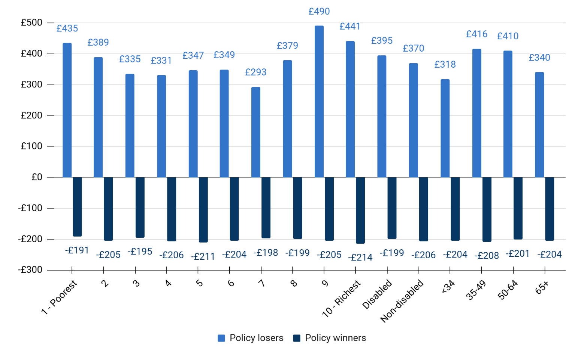

Source: Public First analysis of Living Cost and Food Survey (2022/23) uprated for 2025

**Figure 10: Under a rising block tariff, over a third of low-income and disabled households would see their bills increase.** Percentage of the group losing out from a rising block tariff, by non-mutually exclusive variables of disposable income decile, disability status, and age, GB.

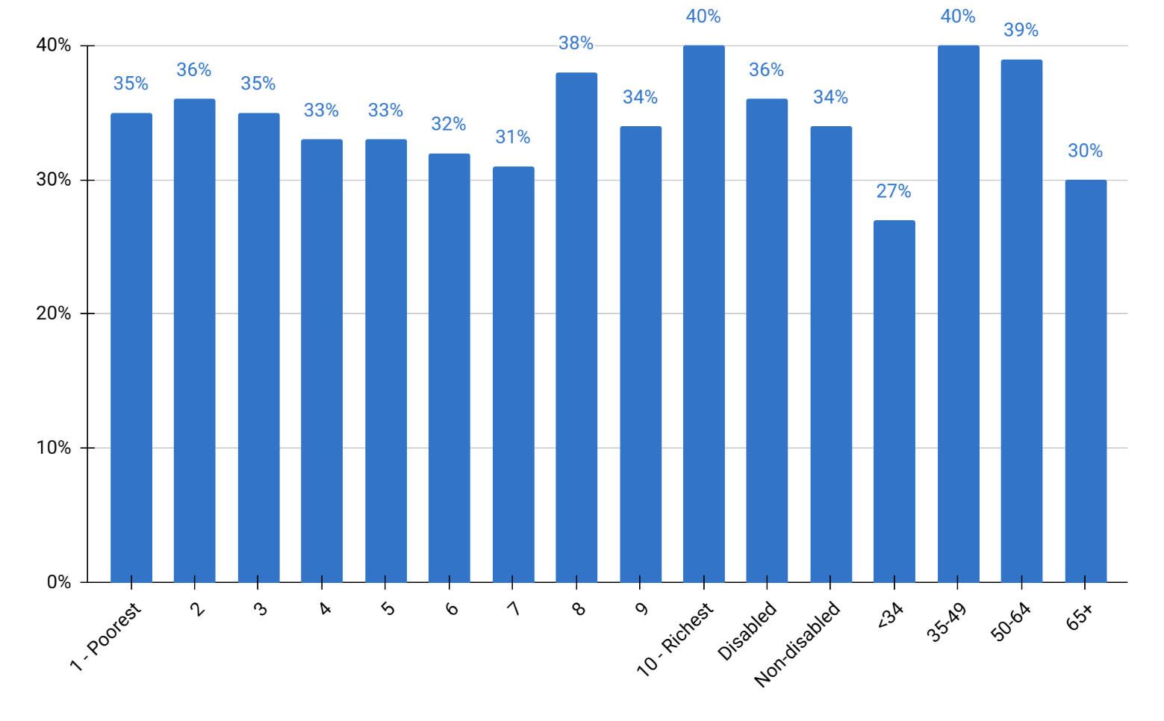

Source: Public First analysis of Living Cost and Food Survey (2022/23) uprated for 2025

### Payment-based vs. unit rate discounts

Payment-based and unit-rate discounts share more similarities, in both cost and impact, than either does with a rising block tariff. When eligibility criteria and average support levels are aligned, the main differences between the two lie in the depth of support (and thus overall policy cost) and how well each approach aligns with broader market developments, such as dynamic pricing and smart technologies.

Unit rate discounts provide deeper levels of support to households with higher energy needs, given that the discount is applied to every unit of energy used. By comparison, a payment-based discount is fixed, meaning it provides the same financial compensation to households, irrespective of how much energy they use (and their ability to change usage patterns) or how much that energy costs. If the policy were to be bill-funded, under a unit rate model of 30%, some WHD-eligible households could benefit from discounts of as much as £1,000, albeit households with higher disposable incomes. Poorer and disabled households would more likely benefit from discounts of between £350 and £450, while older households (over 65) would see reductions of around £300-£350. These savings are broadly comparable to a fixed payment discount of £400, particularly if it were funded through energy bills, as the net gain for eligible households would be approximately £326, once the cost of funding the scheme is factored in.

**Figure 11: Unit rate discounts provide deeper levels of support.** Change in annual energy bill (£) for policy winners of payment-based or unit rate discounts, based on WHD eligibility, by non-mutually exclusive variables of disposable income decile, disability status, and age, GB.

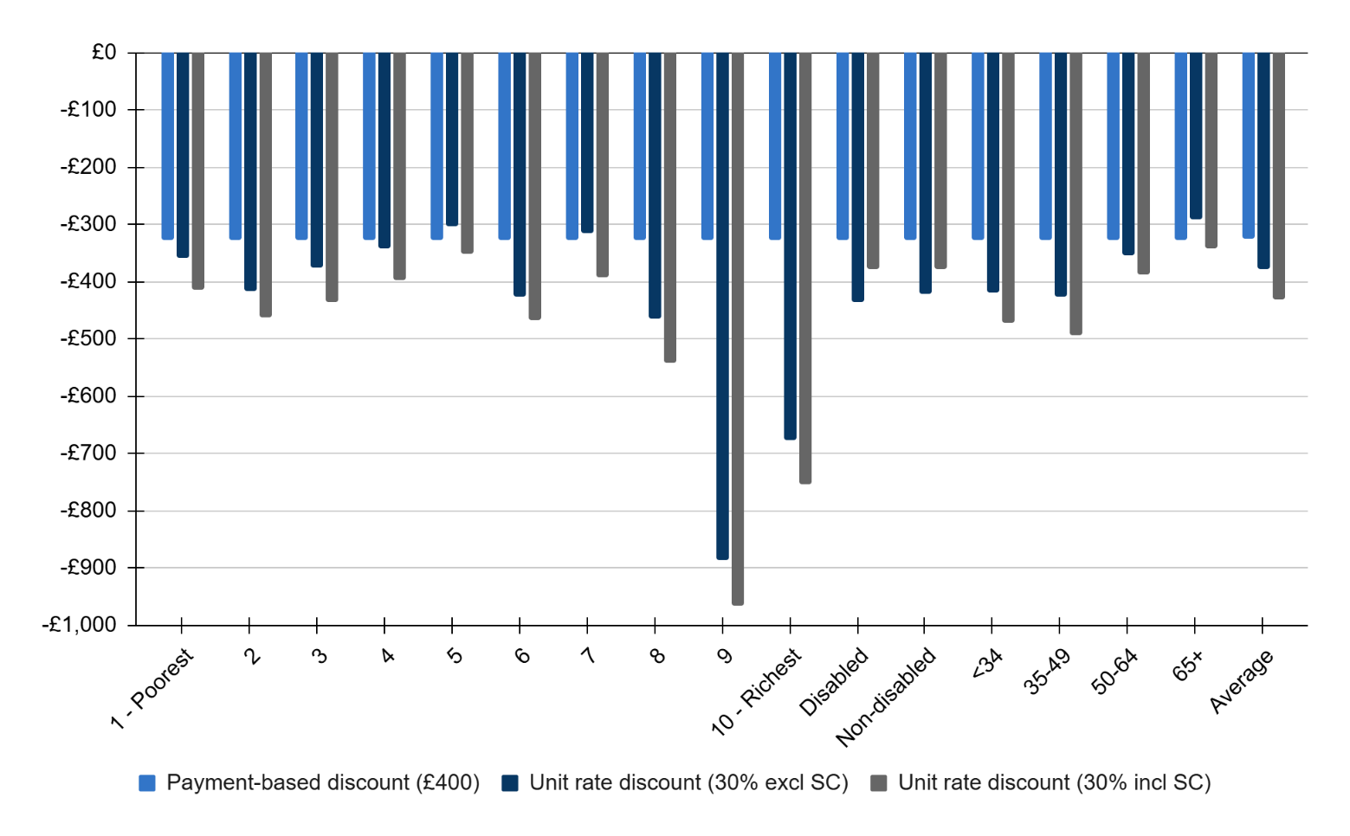

Source: Public First analysis of Living Cost and Food Survey (2022/23) uprated for 2025

Financial constraints on both government and household spending create political challenges for funding targeted bill support. As a result, while the depth of support should be a key consideration for households with high energy needs, policymakers must also consider trade-offs in terms of value for money. Public First research indicates that a payment-based approach is more cost-effective at bringing households out of fuel poverty compared to a unit rate discount. As shown in Table 1, a payment-based discount of £400 could bring the same number of households out of fuel poverty for around £500m cheaper than a 30% unit rate discount inclusive of standing charges (£2.1bn vs £2.6bn respectively). This saving equates to an average of £15 a year per household as modelled for bill-funded policy costs.

Additionally, any model that considers support as a proportion of, or in relation to energy prices, will be more reflective of changing costs. Fixed discounts (either as a pence per-kilowatt-hour or as a set payment) risk having perverse outcomes through either providing inadequate support as energy prices increase or less cost-effective support as prices fall. Options for mitigating this are explored in Chapter Three.

As the energy market shifts towards more dynamic time-based pricing and smart, green technologies, policymakers should also ensure that the chosen model of targeted bill support is compatible with these developments. The case studies below examine how different models of support interact with this market evolution.

### Case study 1: Ensuring targeted bill support design supports fair outcomes in a time-of-use future

Most electricity customers are currently billed based on estimated usage patterns. The upcoming Market-Wide Half-Hourly Settlement reform will allow suppliers to charge based on actual half-hourly consumption, aligning prices more closely with real-time energy costs. This will make it easier to roll out time-of-use (ToU) tariffs, which vary in price by time of day, encouraging people to shift use to off-peak periods. This can reduce system strain and help households cut bills by using cheaper, often cleaner, electricity.

But as the market moves towards these more dynamic pricing models, it is important to recognise the opportunities and risks this creates for consumers. Ofgem’s research[24] suggests that vulnerable consumers could, on average, see a small reduction in bills, but the impact varies significantly across this group, with some experiencing bill increases. For instance, households whose energy use already falls in off-peak periods may benefit without needing to change their behaviour. Others, such as those with fixed routines (e.g. due to caring responsibilities) or without access to smart appliances, may find it harder to shift demand and could see their energy costs increase.

Designing targeted bill support must take account of this changing landscape so that vulnerable customers are not inadvertently left worse off. While the overall shift to ToU pricing should help make the energy system cleaner and more flexible, it is equally important to protect those who are unable to benefit from shifting their consumption. How targeted bill support is structured will shape whether it supports incentives for flexible energy use while still safeguarding vulnerable customers from high bills, and will generate differing trade-offs, including simplicity, protection, and maintenance of price signals in a competitive market.

A fixed payment discount would offer the same amount of support regardless of when electricity is used or its price. This predictability could be especially valuable for households less able to respond to ToU signals, such as disabled households who rely on energy-intensive medical equipment or heating at specific times. Because the discount applies equally across both standard and ToU tariffs, it protects those who choose to stay on a standard tariff while still allowing those on ToU tariffs to benefit from shifting their usage. It is worth noting that a fixed payment discount that did not account for the price of energy would be limited in providing meaningful and cost-effective support, as the discount could become too generous or inadequate depending on volatile energy prices. This is explored in more detail in Chapter 3.

In contrast, a unit rate discount scales with consumption, which can benefit high-use households who have greater energy needs. It also strengthens incentives to shift demand under ToU tariffs, as savings come both from cheaper off-peak prices and the discount per unit consumed. However, this approach is less predictable and risks providing lower overall support for low-use households. In effect, it delivers proportionally greater savings to households with more flexible or higher energy use, rather than guaranteeing a consistent level of support, potentially disadvantaging those who cannot easily change when or how they use energy, such as households relying on medical equipment that must run at fixed times. From an implementation perspective, unit rate discounts are also more complex for suppliers. They require adapting billing systems to apply discounts across different time bands and consumption profiles, which could increase the administrative burden and make the tariff harder to explain to consumers.

A fixed payment may therefore offer a more reliable baseline of support for vulnerable consumers. It does not penalise those who prefer the stability of a flat tariff but still allows people on ToU tariffs to stack savings where they can.

### Case study 2: How would targeted bill support impact consumer engagement with home smart, green technologies?

As the energy system becomes smarter, with more households installing technologies like solar panels, smart heating, or home batteries, the way we support vulnerable consumers must keep pace. A key question is how targeted bill support, designed to protect those struggling with energy costs, interacts with the growing use of green and smart technologies that can also lower bills.

Green and smart technologies help households cut costs by generating their own electricity or shifting usage to cheaper times. According to research by the Resolution Foundation, without additional discounts, rooftop solar could cut household bills by an estimated £440 a year, equivalent to almost a quarter of energy spending for the poorest fifth of households.[25] Where targeted bill support reduces households’ electricity costs, the investment case for energy efficiency measures may weaken, as the value of savings falls. That said, many households eligible for targeted bill support would be on lower incomes and would therefore be unlikely to purchase solar panels or heat pumps outright. They would be more likely to access these technologies through grants or free upgrades.

For households with green technologies already installed, how targeted support is delivered will impact their experiences and benefits. A fixed payment discount offers predictable support regardless of how much energy is used or when. This makes it particularly suitable for households with low or inflexible usage while preserving the full strength of price signals under time-of-use tariffs. Because the discount is not tied to consumption, there is no additional incentive to invest in or make full use of technologies that shift demand, nor does it weaken the case for doing so. A unit rate discount, in contrast, scales with electricity use. This can offer more generous support to households with higher consumption. It also reinforces the incentive to use energy at cheaper times under time-of-use tariffs, by offering an additional per-unit saving. However, this can disproportionately benefit those who can shift demand, rewarding their flexibility, while providing less support to customers who cannot, such as those reliant on medical equipment.

While there may be a behavioural dampening effect from lower electricity prices, the primary role of targeted bill support is to protect struggling households, not to incentivise technological change. That said, it makes it all the more important that other policies support households who *could* significantly reduce their bills by using clean technologies or shifting their energy use. In France, the *chèque énergie* system provides a fixed discount on bills for vulnerable customers, but can also be used for energy efficiency upgrades. A similar approach in the UK could target grants to households with high potential to reduce bills through clean technology and smarter energy use.

To do this well, the government will need better data on household energy needs and usage patterns. A clearer understanding of which households could benefit, and what is stopping them, would allow support to go beyond just discounts. This could reduce long-term reliance on subsidies by helping more people lower their bills through efficient, flexible consumption where possible. Targeted bill support must provide immediate protection, but it should also work alongside wider efforts to build a more inclusive, resilient and low-carbon energy system as considered in the government’s Warm Homes Plan.

# 03 Designing targeted bill support

The previous chapter made the case for adopting a payment-based model for targeted bill support, as it provides cost-effective support that is compatible with an evolving market of dynamic pricing and smart, green technologies. This chapter delves into the key design features of a new payment-based targeted bill discount that addresses the limitations of the existing Warm Home Discount. Specifically, it considers: Who should be eligible? How much support should they receive? How can cliff edges be softened? Who should bear the costs, and what are the distributional impacts?

To answer these questions, Public First modelled two payment-based options for targeted bill support with different eligibility scenarios, detailed in Table 3. These include:

1. **A formula-based payment**, where the level of support is calculated based on certain criteria - in this case, income - to avoid harsh cliff edges of support. Booster flat payments are also modelled to address the need for varying levels of support within eligibility criteria. The formula-based approach modelled tapers support from £700 down to £0 for households with up to £30,000 equivalised household income.
2. **A fixed discount**, whereby eligible households receive the same flat payment off their bills, as is the case with the current WHD. Booster flat payments are also modelled to address the need for varying levels of support within eligibility criteria.

The modelling and analysis of different payment-based approaches to targeted bill support highlights several key design principles and trade-offs that policymakers must navigate when improving and/or replacing the Warm Home Discount.

* **Existing eligibility criteria, based primarily on the benefits system, miss more fuel-poor households than they reach.** Chapter One identified low income and disability as the two strongest predictors of energy affordability pressure, yet many households with these characteristics are excluded under current rules. Expanding criteria to include equivalised household incomes under £30,000 and those on or eligible for disability-related support could reach as many as 9 million households with affordability challenges.
* **Income-based, tapered payments are more cost-effective and fair.** A formula-based discount linked to income delivers deeper and better-targeted support than fixed payment schemes like the WHD. For a similar policy cost, a formula-based income-linked payment could lift 930,000 households out of fuel poverty for £2.4bn, 420,000 more than a fixed, uprated WHD of £400 costing £2.1bn, and reduce the cost of bringing a household out of fuel poverty by over a third.
* **Booster payments help close remaining gaps, bringing hundreds of thousands more households out of fuel poverty.** £100 top-up payments for disabled households and (already eligible) low-income standard credit customers can support those with higher energy needs, bringing as many as 200,000 more households out of fuel poverty for a total of £4.1bn.
* **An entirely-billpayer-funded scheme is regressive and penalises non-recipients.** Funding targeted bill support via energy bills (as WHD is funded) would raise bills for households across all key demographic groups by, under the most expensive scenario, an average of around £100 a year. This undermines fairness, especially for those just above the eligibility threshold.
* **Fiscal constraints warrant consideration of a mixed-funding approach.** An entirely-government-funded bill discount scheme is preferable, as it is more progressive through the tax system than on bills. However, fiscal constraints on public expenditure limit the potential size, generosity and viability of a targeted bill support scheme. As such, policymakers could consider a mixed funding approach, part-funded through taxpayers and billpayers.

Policy costs are modelled as the cost of direct financial support on energy bills. These costs are not inclusive of the existing WHD budget and also do not include wider industry initiative costs. The modelling of average bill changes also includes the cost of the policy to deliver, if it were bill-funded. This is not an endorsement for the policy to be entirely-bill-funded, but rather a helpful guide on costs.

**Table 3: Policy costs and benefits of payment-based targeted bill support scenarios**

|  |  |  |  |  |  |  |  |  |  |  |  |
| --- | --- | --- | --- | --- | --- | --- | --- | --- | --- | --- | --- |
|  | Formula-based payment   (income-linked between £700 and £0 for £30k equivalised household income) | | | Formula-based payment   (income-linked between £700 and £0 for £30k equivalised household income) | Formula-based payment   (income-linked between £700 and £0 for £30k equivalised household income) | Fixed payment (£150 - WHD) | Fixed payment (£400)   (based on expanded WHD eligibility) | | | Fixed payment (£400)   (based on expanded WHD eligibility) | Fixed payment (£400)   (based on expanded WHD eligibility) |
|  | 1. No boosters | 2. +£100 for disability claimants & standard credit customers | 3. +£100 per adult with Equality Act disability & standard credit customers | | | No boosters | No boosters | £100 for disability claimants & standard credit customers | £100 per adult with Equality Act disability & standard credit customers | | |
| Policy cost | £2.4bn | £3.0bn | £4.1bn | | | £0.8bn | £2.1bn | £2.7bn | £3.7bn | | |
| Policy winners | 6.5m | 6.9m | 8.7m | | | 5.3m | 5.3m | 7.1m | 7.2m | | |
| Policy losers | 22.1m | 21.6m | 19.8m | | | 23.2m | 23.2m | 21.5m | 21.4m | | |
| Average change in annual bills (winners) | -£275 | -£277 | -£242 | | | -£122 | -£326 | -£282 | -£295 | | |
| Average change in annual bills if bill-funded (losers) | £80 | £89 | £107 | | | £28 | £74 | £93 | £99 | | |
| Median change in annual bills (winners) | -£253 | -£248 | -£186 | | | -£122 | -£326 | -£307 | -£370 | | |
| Median change in annual bills if bill-funded (losers) | £83 | £106 | £144 | | | £28 | £74 | £93 | £130 | | |
| Change in fuel poverty | -0.93m | -1.01m | -1.13m | | | -0.16m | -0.51m | -0.57m | -0.75m | | |
| Change in fuel poverty for disabled households | -0.54m | -0.60m | -0.72m | | | -0.11m | -0.31m | -0.36m | -0.55m | | |
| Change in fuel poverty for older households (65+) | -0.26m | -0.31m | -0.36m | | | -0.03m | -0.12m | -0.15m | -0.22m | | |
| Value for money i.e. Cost per household brought out of fuel poverty | £2,559 | £3,009 | £3,637 | | | £4,864 | £4,182 | £4,664 | £4,939 | | |

Source: Public First analysis of Living Cost and Food Survey (2022/23) uprated for 2025

Notes: Due to time and self-reporting limitations in the Living Cost and Food Survey, the model does not reflect the exact uptake of the new WHD eligibility, which the government indicates now would benefit 6.1m policy winner households, compared to the modelled 5.3m by Public First. The analysis provides an order of magnitude of the policy impact as well as a guide for the relative ranking of different policy models.

Using the WHD as a baseline, the model assumes support is funded by billpayers, thus reducing the net change in annual bills for policy winners by the average cost of the policy. The total policy cost also reflects the cost to the government if it were tax-funded.

### Eligibility

A key design principle of a new targeted bill support policy is its eligibility, and the need to provide much broader support than what is currently provided through the welfare system. Chapter One of this report highlighted key characteristics of energy affordability and fuel poverty including low income, disability and health conditions, age, payment method and energy efficiency. However, existing mechanisms of support miss more fuel poor households than they help. Recent amendments to both the Warm Home Discount and Winter Fuel Payment eligibility highlight the limitations of our welfare system in finding and defining who needs support.

As illustrated in Chapter One (Figure 3 and Figure 6), low income remains the strongest predictor of energy affordability challenges and fuel poverty, making it a fundamental criterion for better-targeted support. Disability and health also play a crucial role, as many households affected by these factors may not fall into low-income categories but have significantly higher energy needs that strain their budgets. While not all households with high energy needs are captured under these core pillars, many older households or those living in inefficient homes still stand to benefit from existing dedicated schemes such as the Winter Fuel Payment as well as government and industry energy efficiency programmes.

Given the challenges posed by overly complex eligibility systems, the government’s limited progress on improving targeting, and the urgent need to deliver support to vulnerable customers, this report recommends focusing bill support around two core pillars: income and disability. Eligibility should extend beyond the traditional welfare system to include:

* Households with an equivalised household income of £30,000 or less[26]
* Households with at least one member claiming existing disability benefits[27]
* Households outside the disability benefits system with high energy needs, as identified through the Priority Service Register and social prescribing programs.

Public First analysis suggests that over 1.4 million fuel-poor households include a member who has a disability under the Equality Act 2010 but is not in receipt of relevant disability benefits. It is critical that a new scheme can support these households who may also face affordability challenges due to their high energy needs. Expanding the eligibility to include disabled households outside of the welfare system would further increase the scheme’s reach to support households with high energy needs and in some cases, on higher incomes. Clear criteria would be required to identify these households either through the Priority Service Register (PSR) or through the healthcare system, explored in the next chapter. Due to data limitations on the PSR’s makeup, it is unclear just how many households could be included and identified in this group. Using the Equality Act 2010 definition as a proxy for the possible size of this group, Public First analysis of the Living Cost and Food Survey suggests that targeting disabled households beyond the income threshold and relevant benefits could increase the number of policy winners by 1.8 million to a possible total of 8.7 million.

### Level of support

The next key design principle is determining the appropriate level of support for eligible households. In 2024, official DESNZ estimates put the average fuel poverty gap at £407 in England.[28] Public First analysis estimates that the cost of increasing WHD in line with this to £400 per household is £2.1bn a year in total or an annual average of £74 per billpayer, bringing around half a million households out of fuel poverty. However, this fixed payment approach risks overcompensating some households while under-supporting others, and may also create cliff edges in support. In contrast, a formula-based approach can more effectively address these challenges while delivering better value for money, reaching more households out of fuel poverty for a comparable cost.

Public First estimates that for a similar policy cost (around £2.4bn annually, or £80 average per billpayer), a formula-based model could lift approximately 930,000 households out of fuel poverty, about 430,000 more than a fixed £400 payment currently provided by the WHD. Under this approach, the cost per household brought out of fuel poverty is £2,559, compared to £4,182 under a £400 WHD. Improved targeting allows for deeper support (up to £700) to those on the lowest incomes facing the greatest affordability challenges, gradually tapering to zero for households with equivalised incomes above £30,000. On average, this equates to a discount of £275 per eligible household if funded through bills, or £355 if government-funded.

**Figure 12: A formula-based payment has a more progressive distribution than a fixed payment.** Change in annual energy bill (£) for policy winners of a formula-based payment discount (for households with an equivalised income of up to £30,000) and a £400 fixed payment (WHD eligibility), by non-mutually exclusive variables of disposable income decile, disability status, and age, GB.

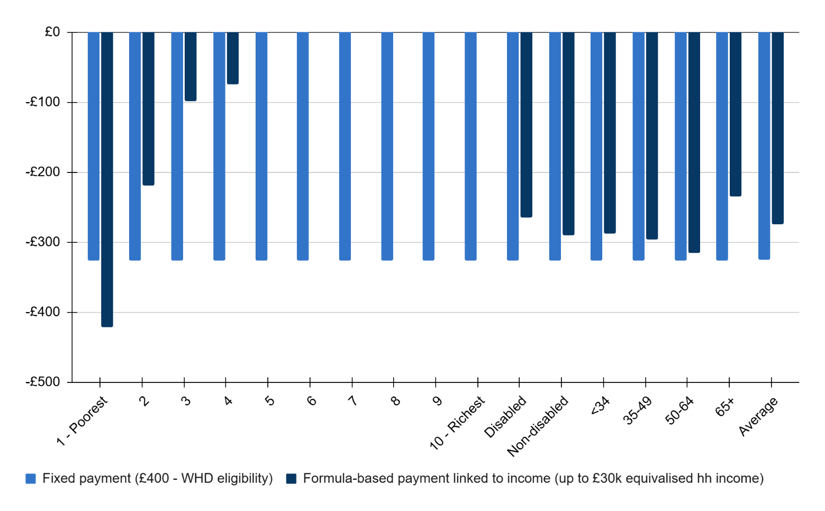

Source: Public First analysis of Living Cost and Food Survey (2022/23) uprated for 2025

Basing the formula solely on income risks excluding households that face higher energy costs for reasons beyond finances. As highlighted in Chapter One, the fuel poverty gap is not just determined by income. On average, standard credit customers face an additional £92 gap for electricity and £59 for gas compared to direct debit customers, as shown previously in Figure 5.[29]

Public First analysis of the Living Cost and Food Survey also estimates that disabled households, as defined under the Equality Act 2010, pay an average of £86 more per year, and disability benefit claimants pay £97 more per year than non-disabled households.

**Figure 13: Disabled households pay on average £86-£97 more per year than non-disabled households for energy.** Average energy expenditure and as a percentage of after housing cost income by disability status, GB.

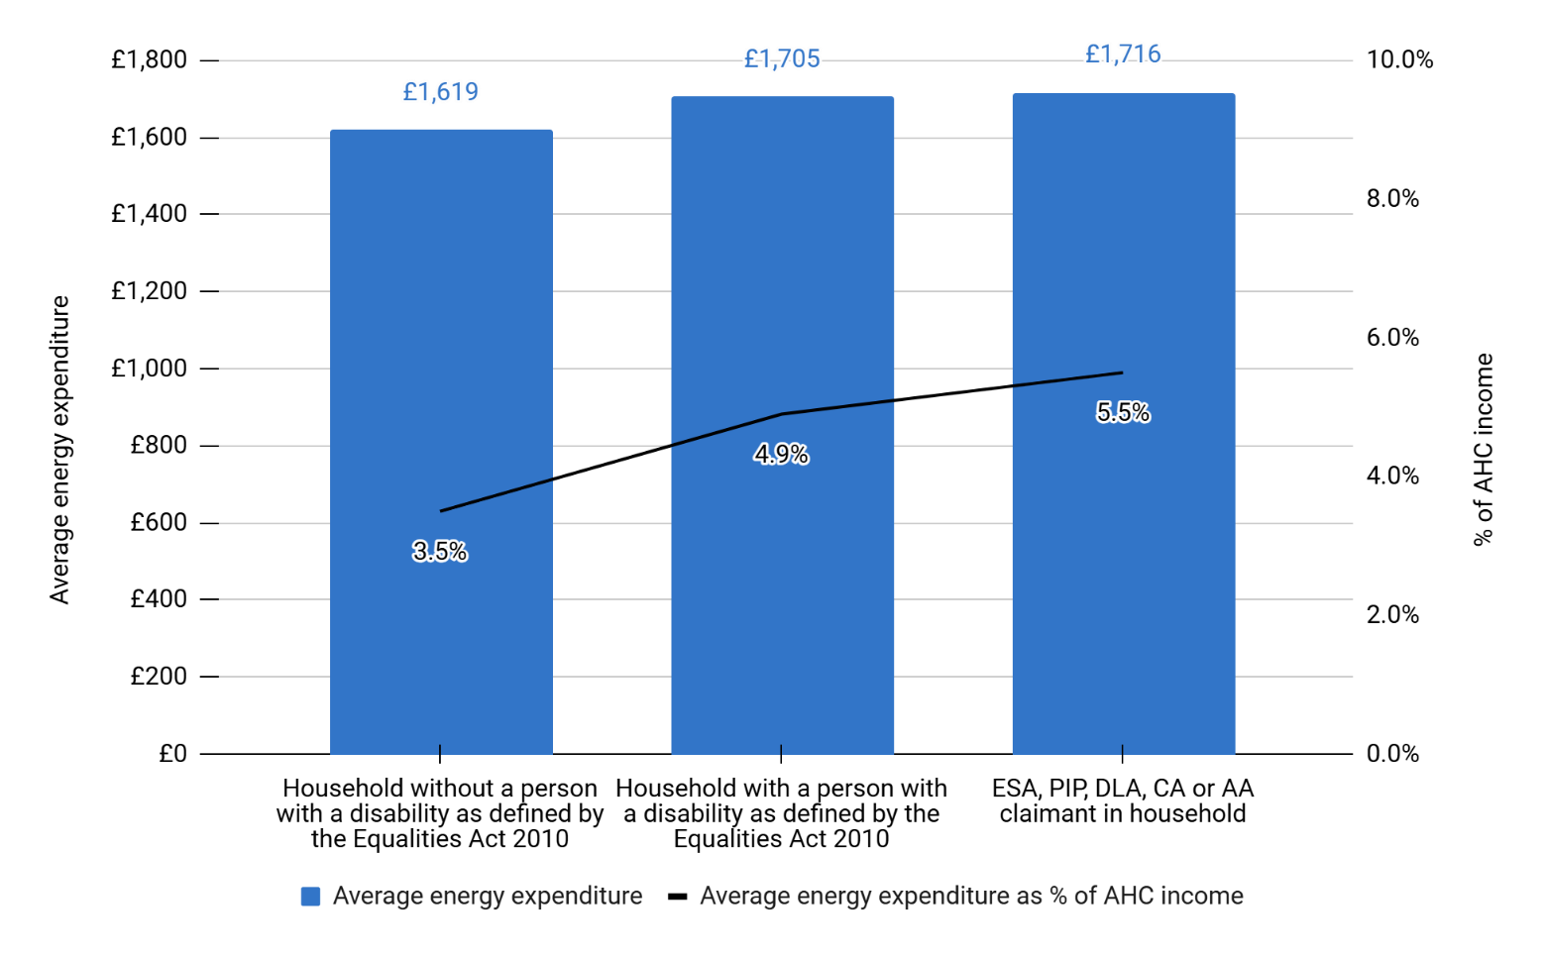Source: Public First analysis of Living Cost and Food Survey (2022/23) uprated for 2025

A booster fixed payment of £100 could reduce this premium for disabled households as well as for standing credit customers who also face a deeper fuel poverty gap of £100 more than direct debit customers, as shown in Chapter One. Public First analysis below illustrates how these payments provide deeper support for households that meet multiple aspects of the low-income, disability and standard credit eligibility, and broader support (albeit a smaller amount) to households that are above the income threshold.

It is worth noting the risk of creating unintended consequences around standard credit customers by introducing a booster payment. This could in theory incentivise customers to stay on standard credit or move away from other payment options towards standard credit, which as a payment method, has higher debt related costs. As such, the £100 booster payment should only be available to customers that are already eligible for the target bill support, within the income threshold.

Looking ahead, policymakers must contend with providing meaningful support to households amidst fluctuating energy prices, while also providing reliable, predictable payments. Unlike the WHD, which has remained at £150 since 2011, targeted bill support should keep pace with changes in energy prices to ensure it is both adequate if prices increase, and cost-effective if prices decrease. Policymakers should commit to an annual adjustment to the value of support tied to, for example, the price cap, the average fuel poverty gap, or other market factors.

The research explores three key scenarios for a formula-based payment:

1. **Income-linked payment only** where support tapers from £700 for those on the lowest incomes down to £0 for households with up to £30,000 equivalised household income.
2. **Income-linked payment plus £100 booster for income-eligible standard credit customers and households claiming relevant disability benefits**, including PIP, ESA, DLA, Attendance Allowance, and Carer’s Allowance.
3. **Income-linked payment plus £100 booster for income-eligible standard credit customers and disabled households, as defined under the Equality Act 2010.**

As shown in Table 2, as the breadth of each policy’s eligibility increases, so does the number of policy winners and the cost of the overall policy, increasing from £2.4bn under Scenario 1 (solely income-linked) up to £3.0bn for Scenario 2 (Boosters for standard credit and disability benefit claimants) and £4.1bn in Scenario 3 (Boosters for income-eligible standard credit customers and disabled customers, under the Equality Act 2010 ). Figures 12 and 14 illustrate the positive and negative distributional effects of this. Figure 12 demonstrates how the breadth of Scenario 3 would benefit over half (52%) of disabled households, as well as over half across the three bottom income deciles, bringing over 1.1 million households out of fuel poverty. By comparison, Scenario 2 supports fewer disabled households but older households (aged 65+), given its inclusion of benefits like Carer’s Allowance and Attendance Allowance. Overall Scenario 2 would still bring over 1 million households out of fuel poverty.

The majority (70% or 3.6 million) of households currently eligible for the expanded WHD would be eligible under Scenario 3, while also reaching a further 5 million households not currently eligible for any targeted bill support.

**Figure 14: Targeting disabled households beyond the welfare system and income threshold would benefit all household groups.** Percentage of policy winners of three formula-based payment discount scenarios, by non-mutually exclusive variables of disposable income decile, disability status, and age, GB.

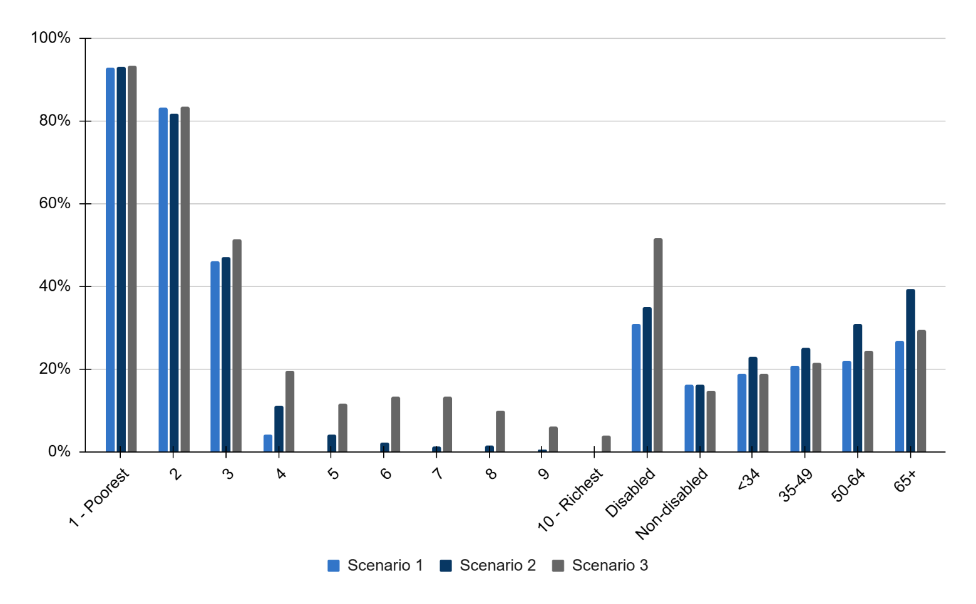  
Source: Public First analysis of Living Cost and Food Survey (2022/23) uprated for 2025

Scenario 1 - Formula-based payment (just income linked). Scenario 2 - Formula-based payment, income-linked plus £100 booster for standard credit customers, and per adult claiming PIP/ESA/DLA/AA/CA. Scenario 3 - Formula-based payment, income-linked plus £100 booster for standard credit customers, and per adult with a disability as defined by the Equality Act 2010

For policy-winning households on the lowest income decile, average bill savings would increase from £421 in Scenario 1 to £434 in Scenario 3, as households are more likely to experience multiple factors of vulnerability. By comparison, average bill savings for disabled or older households (65+) decrease as the policy eligibility widens. This is because more households outside of the income threshold become eligible for just the £100 booster payment, bringing down the overall average. The savings modelled account for the costs of a bill-funded policy to provide a guide for the possible net benefit – these savings would be higher if the policy were to be funded by government or a mixed approach.

**Figure 15: Average savings increase for households facing multiple affordability challenges.** Change in annual energy bill (£) for policy winners of three formula-based payment discount scenarios, by non-mutually exclusive variables of disposable income decile, disability status, and age, GB.

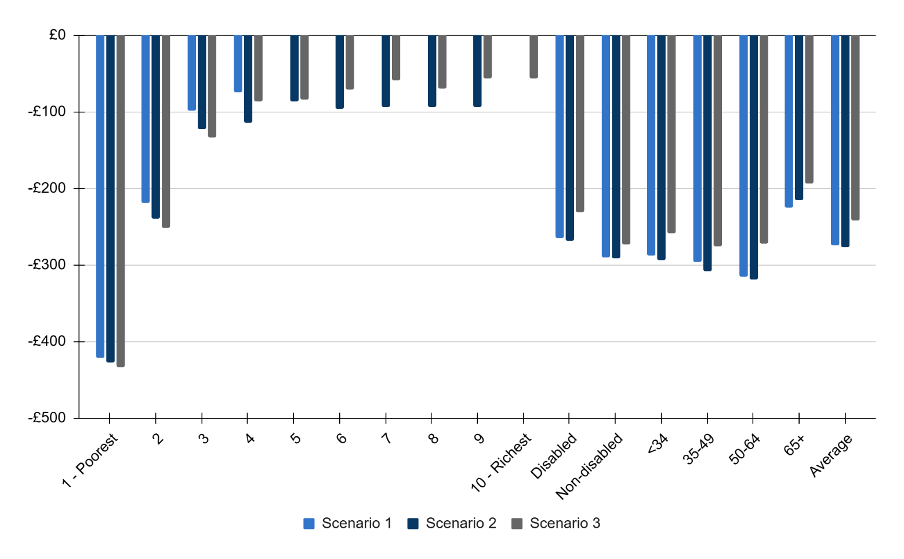

Source: Public First analysis of Living Cost and Food Survey (2022/23) uprated for 2025

Note: Scenario 1 - Formula-based payment (just income linked). Scenario 2 - Formula-based payment, income-linked plus £100 booster for standard credit customers, and per adult claiming PIP/ESA/DLA/AA/CA. Scenario 3 - Formula-based payment, income-linked plus £100 booster for standard credit customers, and per adult with a disability as defined by the Equality Act 2010

Widening the eligibility of the support scheme increases the policy cost, which has negative distributional impacts if the scheme were to be bill-funded. Scenario 1 offers the flattest distribution, with comparatively small but still significant annual bill increases across the board, resulting in an average bill increase of £80 a year. Scenario 3 delivers the highest increase in energy bills across all groups, with an average increase of £107 for policy losers, including significant increases for non-disabled households and those in the upper income deciles, as well as younger households. Scenario 2 sees higher average cost increases than Scenario 1, averaging £89, but does not reach the heights of the costs seen in Scenario 3. Similarly to Scenario 3, though, the biggest losers in Scenario 2 are non-disabled people and people in the upper-income deciles.

**Figure 16: Widening the eligibility of a support scheme increases costs for households in nearly all billpayer groups.** Change in annual energy bill (£) for policy losers of three formula-based payment discount scenarios, by non-mutually exclusive variables of disposable income decile, disability status, and age, GB.

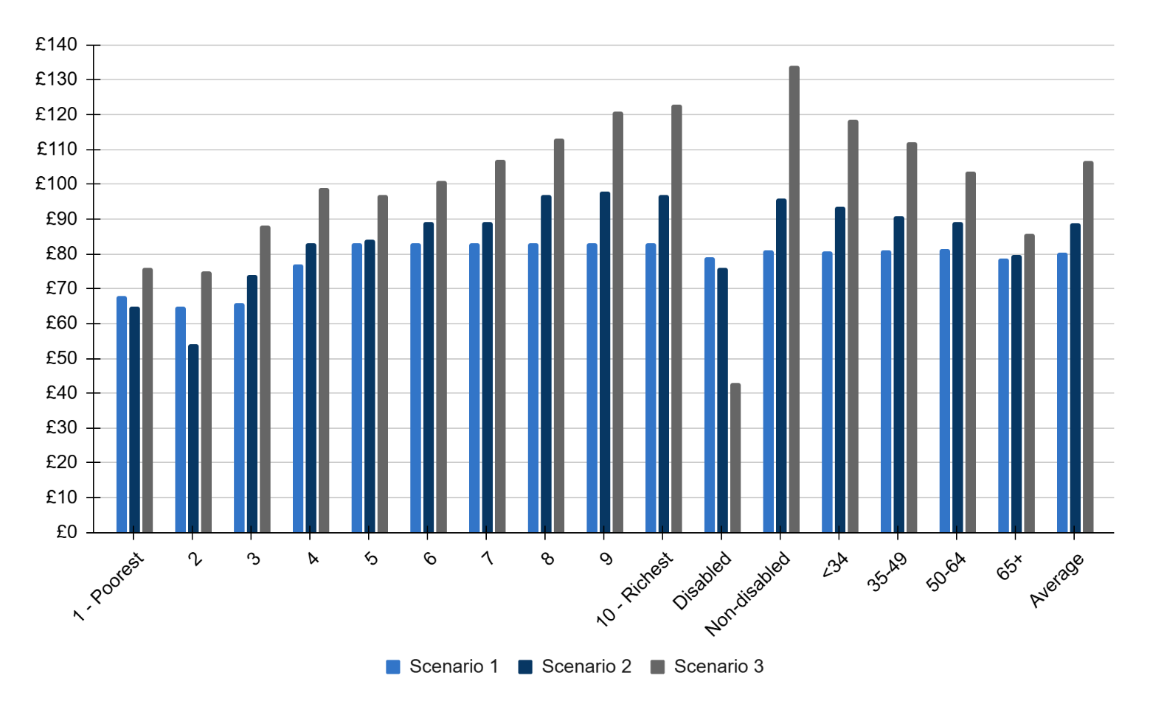

Source: Public First analysis of Living Cost and Food Survey (2022/23) uprated for 2025

Note: Scenario 1 - Formula-based payment (just income linked). Scenario 2 - Formula-based payment, income-linked plus £100 booster for standard credit customers, and per adult claiming PIP/ESA/DLA/AA/CA. Scenario 3 - Formula-based payment, income-linked plus £100 booster for standard credit customers, and per adult with a disability as defined by the Equality Act 2010

### Who pays?

Deciding how targeted bill support is funded is politically and economically challenging given the current constraints on government and household finances with real consequences for fairness and public support. Meanwhile, the cost of energy bills continues to be a key issue for voters, putting pressure on the government to take urgent action on affordability. This report considers three main options: funding through billpayers, government taxation, or industry-led initiatives.

1. **A billpayer-funded approach** is currently how the WHD is paid for. While it may seem administratively straightforward and avoid drawing on public finances, it introduces serious equity concerns. As this report sets out, a bill-funded model would lead to some households across all income levels, age groups, and disability statuses seeing their bills increase to subsidise others. This risks undermining public confidence in the policy and deepening affordability challenges for those who just fall outside the eligibility threshold. Increasing the threshold will continue to drive policy costs higher, reducing support for beneficiaries and creating new cliff-edges which are unsustainable to address.
2. **A government-funded model** delivered through general taxation would be more progressive, distributing costs in line with the ability to pay. It avoids compounding existing energy cost burdens and provides a more stable, transparent funding route. However, there are significant political challenges at a time of competing fiscal pressures.
3. **An industry-led model** could provide funding but would ultimately still be recouped by customers through their energy bills. Further, where suppliers have committed funding, it is largely focused on debt relief, given the scale of arrears totalling £4.15bn in Q1 2025.

An entirely-government-funded bill discount scheme is preferable, as it is more progressive through the tax system than on bills. However, fiscal constraints on public expenditure limit the potential size, generosity and viability of a targeted bill support scheme. As such, policymakers could consider a mixed funding approach, part-funded through taxpayers and billpayers.

# 04 Improving the system for bill support

The current system for identifying and assessing households in need of energy affordability support is not fit for purpose. There is a similar case for this across wider utilities, which should be considered, although the focus of this report is on energy. As outlined throughout this report, meaningful targeted bill support must extend to households beyond the existing welfare system.

An auto-enrolled system for targeted bill support is preferred due to the onus that application-based routes put on households to check their eligibility and apply. This can be particularly onerous for the most in-need, such as disabled households. Additionally, an opt-out system that auto-enrolled all households and relied on able-to-pay households voluntarily opting out of support would not be fiscally responsible. Given the public appetite for cheaper bills amidst the cost of living crisis, it is likely that a significant proportion of households would not opt-out, making the associated policy costs considerable. Below we also explore options for supplementary application-based routes for households that may be missed through an auto-enrolled system, due to data limitations.

Achieving auto-enrolled, income-targeted bill support for households with high energy needs - especially those outside the welfare system - demands a step change from the government. It means overcoming old challenges and developing new mechanisms that cut across departments, energy suppliers, and public services. Success will depend on coordination, data-sharing, and a clear commitment to proactive delivery.

The authors of this report recommended similar action in 2023[30], following the government’s £44bn programme of energy support schemes.[31] Since then, cross-departmental initiatives to improve data matching have made little progress, in part due to a change of government, a lack of political will, and various legislative and bureaucratic blockers. The work required to improve data matching will take time (likely two years) to build the necessary infrastructure – it requires legislative change, new cross-departmental processes, safeguarding measures, and collaboration between government, suppliers and the regulator. But this should not dissuade policymakers from taking swift action. The benefits of improved data matching are clear from this report – enabling policymakers to provide support to vulnerable customers beyond the welfare system, thus better targeting bill discounts and bringing more households out of fuel poverty. The benefits also extend beyond direct financial bill support – an improved data matching system would also help to better identify households eligible for energy efficiency upgrades and those who should be on the Priority Services Register. This could help reduce suppliers’ administrative costs of finding households, which have increased significantly in recent years for delivery energy efficiency schemes.

The ending of the WHD in April 2026 should act as a galvanising moment for policymakers to ensure that a new, improved targeting system is in place ahead of Winter 2027/28. The section below outlines the challenges that must be overcome over the next two years with recommendations to ensure that timeline is achieved. In the meantime, the WHD should be granted a one-year extension to ensure households do not miss out on much needed support. This chapter also considers what near-term changes should be made to the WHD to ensure it provides more adequate support for vulnerable customers.

### Unlocking data to find households in need

The current process for identifying and assessing households for the Warm Home Discount (WHD) relies on the Department for Work and Pensions’ (DWP) system of reviewing benefits and pension eligibility with data shared from other government departments and energy suppliers. While there are lessons to be learned from this process, further steps are required to reach households outside of this system. There are various institutional, privacy, quality and political challenges to achieving this.

**Data ownership is fragmented across government departments and suppliers.** There is no single database that captures all the inputs necessary for assessing income, benefits, health, energy consumption and payment type. HMRC receives income data (both PAYE and self-assessment), DWP manages benefits and pension data, Social Security Scotland, DHSC and the NHS holds health-related data, while energy suppliers know households consumption levels and how they pay. There is little cross-departmental alignment on sharing this data for purposes beyond the existing WHD process. Even though a framework exists, efforts to share data often stall due to bureaucratic caution, perceived legal risks or political sensitivities.

A key challenge is also ensuring officials have the correct skills and resources to ensure a reliable, timely data feed would be sustained between the data processing body and suppliers. Departments, suppliers and the regulator should work together from an early stage to consider the role of a third party intermediary and how to manage data flows. Suppliers and DWP officials will be critical in sharing expertise on working with customer and household data, overcoming technical and operational challenges in data flows, and partnering with other departments to support the integration of a new system. Supplier secondments into the relevant government department or third-party public body could help to smooth this transition process. This work should be overseen by the existing working group led by the Minister for Energy Consumers.

As this report shows, income data is widely evidenced as a critical tool for improving targeted bill support, but there has been little progress between departments to share this data for households outside of the welfare system for many of the following reasons.

**Legal and privacy constraints create political challenges.** The Digital Economy Act 2017 provides a legal basis for the government to share data, such as income or health, for the purpose of tackling fuel poverty. However, primary legislation would be required to expand the purpose further to include supporting a broader cohort vulnerable customers, such as those who would benefit from being on the Priority Services Register. Given that the government is looking to maximise the benefits of data matching for a multitude of reasons, not just targeted bill support, it is prudent that civil service capacity is concentrated on accelerating a single, robust piece of legislative change that encompasses the remit required, as opposed to diverting resource across multiple primary and secondary legislative changes. If policymakers act swiftly to draft and introduce legislation by the end of 2025, which is passed through parliament within 2026, the government can ensure it has the capability for a targeted bill support package within 18 months to two years.

GDPR compliance also remains a concern and risks becoming a wider political debate on privacy. Although energy suppliers already handle personal, sensitive data, steps should be taken to establish a clear, government-endorsed framework for secure and lawful data use. This framework should include either a third-party public body or an existing body, such as DWP, to be the data processor, assess eligible households, and provide suppliers with the redacted information, including an indicator or flag of eligibility. Additionally, ensuring a share-once use-often policy between relevant departments and the data processor would enable data to pass more easily for various affordability and vulnerability purposes.

Any proposals to improve government data matching must also acknowledge the significant lack of trust between the DWP and many benefits claimants. The introduction of the Fraud Bill, with provisions such as potential access to bank accounts, risks reinforcing this distrust and could deter vulnerable customers from seeking support if they fear intrusive monitoring or loss of eligibility. Similar concerns arise with health-related data, where inappropriate use of clinical records could undermine benefits decisions and increase appeals. Building trust and ensuring clear safeguards on how data is accessed and used will therefore be essential for any data-sharing reforms to succeed.

**Income assessment is imperfect.** Given that energy bills are charged to and paid for by households, targeting bill support is most effective when done by households income. However, a key challenge to this is that the government only aggregates household income for Universal Credit and wider welfare purposes. Outside of that system, data is captured by HMRC on an individual basis through PAYE or self-assessments. While HMRC will have a registered address for each individual, data is often outdated with minimal incentive for the public to keep it updated. This poses some challenges to accurately aggregating individual income data into households. Multi-occupancy homes that do not operate as one economic unit (such as young people in flat shares) also add complexity to this aggregation. Policymakers should be emboldened to not let perfect be the enemy of the good when it comes to aggregating income. Monthly data feeds on council tax addresses cross-referenced with HMRC and supplier data should provide a reasonably robust triangulation for many households. Additionally, for self-employed individuals who submit a self-assessment annually, income and address data can suffer from a 12-20 month reporting lag.

Where there are data inconsistencies, households could be identified through wider means, such as the Priority Service Register or smart meter data available to suppliers. Based on their payment method, arrears, consumption patterns, health data etc., households could then be contacted as part of a campaign to say, “we think you might be entitled to an energy bill discount, please update your address here.”

**The Priority Services Register (PSR) needs clearer needs codes for vulnerable customers.** Existing tools like energy suppliers’ Priority Services Register can help identify vulnerable customers, as it already keeps record of specific needs such as age, disabled, or medical requirements to receive support during emergencies like a power cut. However, in its current form, the Priority Services Register includes over 30% of all households without clear ways of identifying how these customers could be best supported. Meanwhile, research by Vulnerability Registration Service finds that 63% of people who would be eligible for the Priority Services Register have not heard of it.[32] Ensuring the Priority Services Register adequately captures vulnerable customers and signposts their needs for support.

Stakeholders have called for improvements to refine needs codes to differentiate between different types of vulnerability i.e. disability and health versus financial. These codes and characteristics could then be shared as part of a flagged list from suppliers to the designated data processor and assessor, whether that be a third-party public body or existing government department. This work will require action by Ofgem to undertake an analysis of potential health-based needs codes and the data required to qualify them, working with partners in the healthcare partners, energy suppliers, District Network Operators, Gas District Network, water companies and Ofwat on how that data can be used.

This again would extend beyond the Digital Economy Act’s remit of sharing data for the purpose of reducing fuel poverty, as wider vulnerabilities are also captured in the data. Expanding the Act’s purpose would enable the government to not only improve data matching for targeted bill support, but also for other affordability services like debt relief and energy efficiency schemes.

**Wider forms of reporting could also help identify households for targeted bill support.** Further services should be available to refer households for bill support, either through healthcare services or self-reporting routes when households enter a sudden change of circumstance or ‘crisis’ (i.e. redundancy, bereavement etc.).

Recent trials of the Warm Homes Prescription (WHP) by the Energy Systems Catapult highlight how social prescribing in NHS partners and local energy advice organisations can support vulnerable and low-income customers with immediate relief for living in warmer temperatures, including energy bill support and energy efficiency. The trial found that 93% of delivery staff delivering WHP would like to see the NHS offer it again in winter, and 94% of healthcare professionals were satisfied with the WHP experience, finding it easy to integrate within their routine workload. Among 823 recipients, 79% reported physical health improvements and 70% reported better mental health after receiving WHP. Recipients saw lower usage of primary healthcare services (e.g., GP visits, out-of-hours appointments and prescriptions) compared to prior winters, and there was some indication of reduced overnight hospital stays, suggesting WHP may alleviate pressure on NHS services. This model was said to be replicated and scaled with partners in NHS, energy advisors and suppliers.[33] Policymakers in DHSC should learn the lessons from this and consider how suppliers and health providers can scale social prescribing as a route to identifying vulnerable customers for targeted bill support.

Application routes, such as the one Scotland has for the WHD Broader Group, could also provide a pathway for vulnerable customers who may be missed by auto-enrolment due to data inaccuracies. These routes can be particularly onerous for the most in-need, such as disabled households, so accessibility provisions must be considered in its design. However, disabled households would be otherwise well supported through wider recommendations for income data-matching, social prescribing, the Priority Services Register reforms.

Self-reporting routes are harder to facilitate to work with the right partners and ensure they are inclusive with the right design tools, which can be an onerous and expensive process. These routes should still be invested in and available, but decisionmakers and stakeholders should be aware that it is not a quick win over progressing with income data matching and coding the Priority Services Register.

Many of the challenges and solutions set out above include both administrative hurdles and political risk. It is reasonable for politicians to worry about privacy concerns and data quality issues that cause mistakes – either in-need households missing out or the wrong households benefiting from other taxpayers or billpayers’. However, this fear has paralysed action for too long with limited progress since the energy crisis began over four years ago. Below, we set out clear near-term and longer-term actions that the government can take to accelerate a new and improved targeted bill support scheme.

### Extending WHD and improving targeted bill support

As highlighted above, it will likely take 18 months to two years for the government to sufficiently build the data matching infrastructure, with the necessary legislative and safeguarding processes, for a targeted bill payment mechanism that supports vulnerable customers outside of the welfare system. Policymakers should aim for the payments to be implemented by Winter 2027/28.

Over this time, it is critical that policymakers:

* **Provide adequate support to vulnerable customers until the new system of targeted bill support is ready to implement. This includes:**
  + Committing in 2025 to extend the WHD by one year (to April 2027) to ensure that vulnerable customers do not miss out on support. If timelines for implementing a new system of targeted bill support (outlined below) encounter delays, policymakers must ensure there is no gap in support and consider extending the WHD for a second year to April 2028.
  + Increasing the WHD to £400 in line with the average fuel poverty gap for Winter 2026/27 with £100 booster payments to WHD-eligible standard credit customers and a £100 payment to disability benefit claimants. This will cost £2.7bn a year or an average of £93 per policy loser if funded entirely on bills. It would also bring over half a million households out of fuel poverty, compared to around 220,000 under the current £150 WHD scheme.

* **Build a new system of targeted bill support, collaborating across departments, local authorities, Ofgem, and suppliers.** With swift action, this process will take around 18 months to 2 years to set up and implement by Winter 2027/28.
  + Launch the expected targeted bill support (also known as social tariff) consultation by Autumn 2025.
  + Ensure the existing ministerial working group on data matching stays in place until the system is implemented, facilitating shared best practice and expertise across departments and suppliers, and supporting secondments where necessary.
  + Draft primary legislation, to update the Digital Economy Act 2017 for the purpose of wider data sharing for supporting vulnerable customers, over the rest of 2025 to launch and pass through parliament by the end of 2026.
  + Appoint a trusted data processor (e.g. DWP or a third-party public body) in 2026 to assess eligibility and provide suppliers with redacted eligibility flags.
  + Pilot triangulation of address data by cross-referencing council tax addresses, HMRC income records, and supplier data to support aggregating income data into households within 2026.
  + Complete aggregation of HMRC’s income data into households to improve accuracy of income-linked household targeting by Spring 2027.
  + As part of the bill allocation and affordability review announced in July 2025, Ofgem should consider the role of targeted bill support and work with suppliers to introduce needs codes to the Priority Services Register which indicates what support they would benefit from. Ofgem should undertake an analysis of potential health-based needs codes and the data required to qualify them, working with partners in the healthcare industry and suppliers on how that data can be used.
  + Implement lessons from the Warm Homes Prescription pilots and consider how suppliers and health providers can scale social prescribing as a route to identifying vulnerable customers for targeted bill support throughout 2026 and 2027.
  + Invest in building inclusive, well-designed self-referral tools that allow households experiencing sudden life shocks (e.g. bereavement, redundancy) to access targeted bill support.

An estimated timeline of these actions is presented below.

**Table 4: Summary of policy recommendations and timeline**

Note: For accessibility, the x denotes a coloured square in the timeline.

|  |  |  |  |  |  |
| --- | --- | --- | --- | --- | --- |
| **Action** | **Responsibility** | **2025** | **2026** | **2027** | **2028** |
| Extend the WHD to April 2027, increasing eligibility value to £400 plus booster payments | DESNZ/HMT | x |  |  |  |
| Launch the target bill support consultation by Autumn 2025 | DESNZ | x |  |  |  |
| Keep ministerial working group on data matching in place until full implementation | DESNZ | x | x | x | x |
| Draft primary legislation to update the Digital Economy Act 2017 | DESNZ | x |  |  |  |
| Pass the legislation through parliament | DESNZ |  | x |  |  |
| Appoint a trusted data processor (e.g. DWP or third-party) | DESNZ |  | x |  |  |
| Pilot triangulation of household address data | HMRC, VOA/local authorities & suppliers |  | x |  |  |
| Apply lessons from Warm Homes Prescription pilots to scale social prescribing | Appointed data processor, suppliers & healthcare providers |  | x | x |  |
| Invest in building inclusive, well-designed self-referral tools | Appointed data processor & suppliers |  | x | x |  |
| Undertake an analysis of potential health-based needs codes for the Priority Services Register | Ofgem, DNOs, GDNs, Ofwat, water companies, suppliers & healthcare providers |  | x |  |  |
| Implement needs codes for the Priority Services Register | Ofgem & suppliers |  | x | x |  |
| Complete household aggregation of income data | HMRC |  |  | x |  |
| Implement a formula-based income-linked targeted bill support payment | DESNZ, HMT, appointed data processor & suppliers |  |  | x | x |

# Annex

## A1. Methods

To model the impact of different types of billpayer-funded social tariffs on fuel poverty rates and energy bills - and how these impacts vary across different groups (income deciles, disability statuses, age groups), we drew on data in the 2022/23 Living Costs and Food Survey (LCFS). This is the most detailed official dataset on household spending patterns. It also contains variables on household incomes, demographics and receipt of benefits.

Using data in the LCFS on electricity and gas (e.g. oil, coal) expenditure, we were able to model how individual household energy bills change in response to lump sum or unit rate social tariffs, and a rising block tariff. The LCFS expenditure does not split outstanding charges and variable energy costs; therefore, we estimated variable versus fixed energy costs using Ofgem data on average standing charges ([here](https://www.ofgem.gov.uk/standing-charge-electricity-and-gas)).

Data on energy expenditure was uprated into 2024/25 values using ONS consumer price index data for gas and electricity prices. Household income has also been uprated, using Labour Force Survey data on earnings growth and relevant uprating rates for benefits.

Data on household incomes, benefits and disability statuses were used to explore the implications of different eligibility assumptions for a social tariff.

By comparing pre and post-social tariff energy bills, we were able to estimate the change in the number of households in fuel poverty. Fuel poverty is defined as spending more than 10% of after-housing costs income on energy.

Distributional analysis by income group looks at equivalised deciles of household income after housing costs. Equivalisation to account for different household sizes is done using the McClements equivalence scales. More data on this is available [here](https://www.gov.uk/government/statistics/households-below-average-income-for-financial-years-ending-1995-to-2020/household-below-average-income-series-quality-and-methodology-information-report-fye-2020).

To model the impact of reduced PIP entitlement in the future - with potential knock-on implications for social tariff eligibility - we drew on estimates [here](https://www.disabilityrightsuk.org/news/90-pip-standard-daily-living-component-recipients-would-fail-new-green-paper-test?srsltid=AfmBOoqmQ3P5dOjAdDj05zMv_n8Mk8gUnJEKYnjJ0WwmJYitA_QZF_cd) on the proportion of standard and enhanced PIP claimants that would lose out under a “4-point rule”. This was then used to probabilistically remove PIP from households in the LCFS dataset. This is very much an approximation of impact, given the LCFS lacks sufficient data to establish which households are more likely to lose out.

To aggregate up from the LCFS to population-wide numbers, we use the weighting variable included in the LCFS.

**Limitations and caveats**

While the LCFS is the best and most appropriate dataset for this analysis, it is not without its flaws. As a survey, data on e.g. receipt of certain benefits might be under or overreported. Similarly with income and expenditure data. As such, model estimates are very much “order of magnitude” estimates presenting the most accurate picture possible with the data available. We also believe that the relative ranking of policies is likely to hold true both in reality and within the data itself.

***Overview of LCFS variables used***

**On disability status:**

Healill = Have you got a physical mental health cond lasting more than 12 months?

Redact = To what extent does this condition impact your day-to-day life (a lot, a little, not at all)

**On age of household:**

A065p = Age of household reference person

**On equivalised income net of housing costs:**

P389p = Normal weekly disposable hhld income

P515tp = Net housing costs

Mcs = equivalisation factors

**Benefits and tax credit variables:**

p204 = housing benefit

B552 = PIP (care component) - last amount received

B553 = PIP (mobility component) - last amount received

B403 = DLA (self-care)

B405 = DLA (mobility)

P027 = ESA amount

B421 = Attendance Allowance - the last amount received

B343 = Invalid care allowance - last amount received

P024 = Job Seekers Allowance amount

P025 = Income support amount

B3651 = Pension credit amount

B550 = Universal Credit amount

Dvctc = child tax credit amount

Dvwtc = working tax credit amount

**On energy expenditure:**

B170 = gas amount paid in last account

B1701 = separate gas meter payment

B226 = Gas component of a combined utility bill

B173 = Rebate for the separate Gas amount

B175 = Electricity amount paid in last account

B1751 = Separate electricity meter payment

B227 = Electricity component of a combined utility bill

B178 = Rebate for separate Electricity amount

B174 = Rebate for combined gas and electricity

B233 = Combined gas and electricity - pre-payment meter

B017= Amount spent on oil for heading  
B018 = Amount spent on bottled gas for heating

**On energy payment method (used to identify standard credit customers):**

A128 = Gas - method of payment

A129 = Payment method for combined gas electric

A130 = Electricity - method of payment

## A2. Additional unit rate discount scenarios

The scenarios featured in Table 4 were also modelled for a unit rate discount, building on the Warm Home Discount eligibility to also include disabled households, given that disability benefits were not included in the WHD expansion. These scenarios do not feature in the main report as the unit rate discount model was ruled out in favour of a payment based model due to value for money and compatibility with a competitive, dynamic and evolving market. A formula-based income-linked unit rate discount was not modelled as the unit rate approach was ruled out ahead of this stage of the analysis.

**Table 5: Policy costs and benefits of a 30% Unit Rate Discount.**

|  |  |  |  |  |  |  |
| --- | --- | --- | --- | --- | --- | --- |
|  | Warm Homes Discount eligibility | | Warm Home Discount eligibility + PIP, DLA, AA & CA eligibility | | Warm Home Discount eligibility + disability | |
|  | Including Standing Charge | Excluding Standing Charge | Including Standing Charge | Excluding Standing Charge | Including Standing Charge | Excluding Standing Charge |
| Policy cost | £2.4bn | £2.0bn | £2.4bn | £2.0bn | £6.6bn | £5.3bn |
| Policy winners | 4.9m | 4.6m | 4.9m | 4.6m | 11.36m | 10.13m |
| Policy losers | 23.6m | 24.0m | 23.6m | 24.0m | 17.18m | 18.41m |
| Average change in annual bills (winners) | -£408 | -£354 | -£408 | -£354 | -£320 | -£304 |
| Average change in annual bills if bill-funded (losers) | £84 | £68 | £84 | £68 | £211 | £167 |
| Median change in annual bills (winners) | -£326 | -£277 | -£326 | -£277 | -£239 | -£222 |
| Median change in annual bills if bill-funded (losers) | £85 | £68 | £85 | £68 | £230 | £186 |
| Change in fuel poverty | -0.52m | -0.40m | -0.52m | -0.40m | -0.96m | -0.76m |
| Change in fuel poverty for disabled households | -0.36m | -0.26m | -0.36m | -0.26m | -0.91m | -0.76m |
| Change in fuel poverty for households with a 65+ household representative person | -0.15m | -0.13m | -0.15m | -0.13m | -0.40m | -0.35m |
| Value for money i.e. Cost per household brought out of fuel poverty | £4,628 | £4,895 | £4,628 | £4,895 | £6,862 | £6,939 |

Source: Public First analysis of Living Cost and Food Survey (2022/23) uprated for 2025

1. Public First, New polling for NESO, July 2025. 9,758 sample of British adults from 5-16th December 2024.
2. Ofgem, Number of domestic smart prepayment meter customers self-disconnecting at least once, March 2025.
3. Ofgem, Total financial value of domestic customer debt and arrears (existing for more than 91 days), March 2025.
4. Difference between direct debit price cap prices from July-September 2025 and 2020/21 winter. Ofgem, Costs included in price cap level, May 2025
5. Department for Energy Security and Net Zero, Annual fuel poverty statistics, 2025.
6. Department for Energy Security and Net Zero, Annual fuel poverty statistics, March 2025.
7. House of Commons Library, Fuel poverty in the UK, April 2025.
8. Housing Executive, House Condition Survey Northern Ireland, 2016
9. National Energy Action, ‘Too scared to turn on the heat’ – 40% of Northern Irish households are still in fuel poverty, November 2024.
10. National Energy Action, ‘Timeline of the energy crisis’, April 2025.
11. Committee on Fuel Poverty, Can Fuel Poverty be Ended? Annual Report 2024, August 2024.
12. London Economics, Understanding the challenges faced by fuel poor households, May 2023.
13. London Economics, Understanding the challenges faced by fuel poor households, May 2023
14. *Department for Energy Security and Net Zero, Annual fuel poverty statistics, 2024.*
15. *Independent Water Commission, Final report, June 2025.*
16. *For example Centre for Sustainable Energy, Social tariffs – a solution to fuel poverty?, April 2006.*
17. Department for Energy Security and Net Zero, Expanding the Warm Home Discount Scheme, 2025 to 2026: consultation document, February 2025.
18. Department for Energy Security and Net Zero, Consultation outcome: Expanding the Warm Homes Discount Scheme, 2025 to 2026, June 2025
19. Department for Energy Security and Net Zero, Annual fuel poverty statistics, 2025
20. Institute of Fiscal Studies, Expanding Winter Fuel Payment eligibility, 2025.
21. The Guardian, Winter fuel payment cuts may force 100,000 pensioners below the poverty line, November 2024
22. The Social Market Foundation, Fairer, warmer, cheaper: New energy bill support policies to support British households in an age of high prices, March 2023
23. National Audit Office, Energy bills support: an update, November 2024
24. Ofgem, Distributional impact of time of use tariffs, May 2017 in Ofgem, Market Half Hourly Settlement Final Impact Assessment, April 2021
25. *Resolution Foundation, Sunny day savings, February 2025*
26. Excluding PIP from income calculations. PIP is a benefit designed to help with the extra costs associated with a long-term health condition or disability.
27. Public First modelling includes benefits of Employment and Support Allowance, Personal Independence Payment, Disability Living Allowance, Carer’s Allowance and Attendance Allowance. Targeted support should also include devolved disability benefits of Adult Disability Payment, Pension Age Disability Payment, Carers Support Payment, and Child Support Payment.
28. Department for Energy Security and Net Zero, Fuel poverty statistics, England, 2024, March 2025
29. Figure 5 - Department for Energy Security and Net Zero, Fuel poverty statistics, England, 2024, March 2025
30. The Social Market Foundation, Fairer, warmer, cheaper: New energy bill support policies to support British households in an age of high prices, March 2023
31. The National Audit Office, Energy bills support: an update, November 2024
32. Vulnerability Registration Services, 80% of UK adults have never heard of the Priority Services Register, new research reveals, March 2023.
33. *Energy Systems Catapult, Warm Home Prescription recommended by 93% of health professionals in latest trial, September 2023.*